 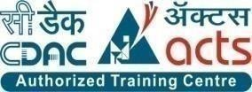

**INSTITUTE FOR ADVANCED COMPUTING AND SOFTWARE DEVELOPMENT (IACSD), AKURDI, PUNE**

Documentation On

Social Complaints Portal

PG-DAC March 2023

# Submitted By:

**Group No: 23**

**Roll No. Name:**

**233039 Harshit Parmar**

**233104 Tambade Shirish R.**

# Mrs. Megha Mane Mr. Rohit Puranik

**Project Guide Centre Coordinator**

# ABSTRACT

This project is a web-based Social Complaints Portal for the municipal corporation and citizens. The project objective is to manage the social problems from web platform.

The system is an attempt to provide the advantages of online managing and storing data of the issues and complaints. It helps to stay updated and manage the social issues or data from anywhere through internet by using a website device. Thus, without using paper or pen or gathering all the citizens in the meeting, one can get updated using the website portal.

This will be beneficial to all the members who travel abroad and who cannot be a part of each and every notice of the city. This application will travel worldwide and any members will have an access to it. Understanding the needs of the citizens and to overcome the manual work of the documentation and make it online which will be feasible and flexible and try to make it user friendly.

# ACKNOWLEDGEMENT

I take this occasion to thank God, almighty for blessing us with his grace and taking our endeavor to a successful culmination. I extend my sincere and heartfelt thanks to our esteemed guide, **Mrs. Megha Mane** for providing me with the right guidance and advice at the crucial juncture sand for showing me the right way. I extend my sincere thanks to our respected **Centre Co-Ordinator Mr. Rohit Puranik**, for allowing us to use the facilities available. I would like to thank the other faculty members also, at this occasion. Last but not the least, I would like to thank my friends and family for the support and encouragement they have given me during the course of our work.

#### Harshit Parmar (223039)

**Tambade Shirish R. (223104)**

# Table of Contents

ABSTRACT 1

ACKNOWLEDGEMENT 2

INTRODUCTION 6

FEATURES 6

* 1. PROJECT OBJECTIVE 7
  2. PROJECT OVERVIEW 7
  3. PROJECT SCOPE 8
  4. STUDY OF THE SYSTEM 8

SYSTEM ANALYSIS 16

* 1. EXISTING SYSTEM 16
  2. PROPOSED SYSTEM 16
  3. SYSTEM REQUIREMENT SPECIFICATION 16

SYSTEM DESIGN 19

* 1. INPUT AND OUTPUT DESIGN 19
     1. INPUT DESIGN 19
     2. OUTPUT DESIGN 19

DATABASE DESIGN 21

* 1. DATABASE 21
  2. SYSTEM TOOLS 21
     1. FRONT END 21
     2. BACKEND 21

1. LEVEL DFD 22
2. LEVEL DFD FOR ADMIN 23

1 LEVEL DFD FOR OFFICIALS 24

1 LEVEL DFD FOR CITIZENS 25

E-R DIAGRAM 26

CLASS DIAGRAM 27

TABLE STRUCTURE 28

PROJECT DIAGRAMS 29

CONCLUSION 50

REFERENCES 51

**LIST OF FIGURES**

#### FIGURE: ACTIVITY DIAGRAM 11

**FIGURE: 0 LEVEL DFD 23**

#### FIGURE: 1 LEVEL DFD FOR ADMIN 24

**FIGURE: 1 LEVEL DFD FOR OFFICIALS 25**

#### FIGURE: 1 LEVEL DFD FOR CITIZENS 26

**FIGURE: E-R DIAGRAM 27**

#### FIGURE: CLASS DIAGRAM 28

**FIGURE: TABLE STRUCTURE 29**

**FIGURE: PROJECT DIAGRAMS 32**

# INTRODUCTION

Social Complaints is a Web based Platform which is a single window platform wherein the citizens can easily register their complaints, provide suggestion or feedback on various issues and connect with local Government Officials to resolve any kind of issues. The platform allows citizens to upload the images and exact location of the problem, whereas the worker can upload the image when the work is completed. System supports google map integration to help the user to find out where is the exact problem location. System supports roles mainly as citizen, government officials, actual workers and administration who performs their respective roles.

System manages the complete end to end complaint management or complaint flow starting from citizen to the worker end, which helps in making the whole process transparent and flexible for the citizens and eliminates the delay in getting problem resolved.

## Features: -

1) Visual Proof:

Capturing and uploading the snap of the problematic zone as a visual proof.

2) Complaint Management:

Department Wise Sorting

Schedule Complaint

3) Update Status

4) Status

User can see status regarding complaints

5) Worker Allocation

6) Officials will assign task to the workers

7) Analytics Chart of

All Complaints/Resolved Complaints/Pending Complaints

## PROJECT OBJECTIVE

The main functionality of this project is that, accessing complaint details and its management anywhere anytime and from any platform or device. There is an online complaining and issue solving. In this system the bills and receipts are easily maintained and also the system is user friendly.

## PROJECT OVERVIEW

The application designed into three modules first one is the admin who has full access to the application. Second one is the official who can manages tasks that are all related to his/her department only. Third module is citizen who can only add or delete complaints and check status. Admin can add or delete or update the data of officials or work staff.

Admin gives limited access of this system to officials and citizens. The data related with the user details and its owner stored by Admin on database through system. Admin is able to assign complaints which can be viewed by that official only. Admin circulates the notice using the system and this notice can be viewed by all officials. Officials may assign complaint for his/her department and can save complaint details on database through the system. Citizens may raise the complaint through the system which can be viewed and solved by Admin, Officials and Workers and its status get changed from pending to completed. Officials can add his complaint status details on database through the system.

## PROJECT SCOPE

This system provides friendly user interface to every citizen. The various other functionalities about Cross browsing, various categories suitable for different departments etc. This application will help all sectors of people which will provide them visibility and smooth functioning. This will be beneficial to all the members who travel abroad and who cannot be a part of each and every issue of city. This application will travel worldwide and any members will have an access to it. Understanding the needs of the citizens and to overcome the manual work of the documentation and make it online which will be feasible and flexible and try to make it user friendly. Web-platform means that the system will be available for access 24/7 except when there is a temporary server issue which is expected to be minimal.

## STUDY OF THE SYSTEM

## MODULES:

The system after careful analysis has been identified to be presented with the following modules and roles.

The modules involved are:

* + - * Admin
      * Officials
      * Citizens
      1. Admin:

The admin is the super user of this application. Only Admin have access into this Admin page. Admin is the employee from authorities. The admin has all the information about the other officials and about all work staff.

This module is divided into different sub modules.

* + - * 1. Manage Officials
        2. Manage Work staff
        3. File Complaints
        4. Manage Complaint
        5. Manage Complaint Status
        6. Add Officials/Workers and register Citizens

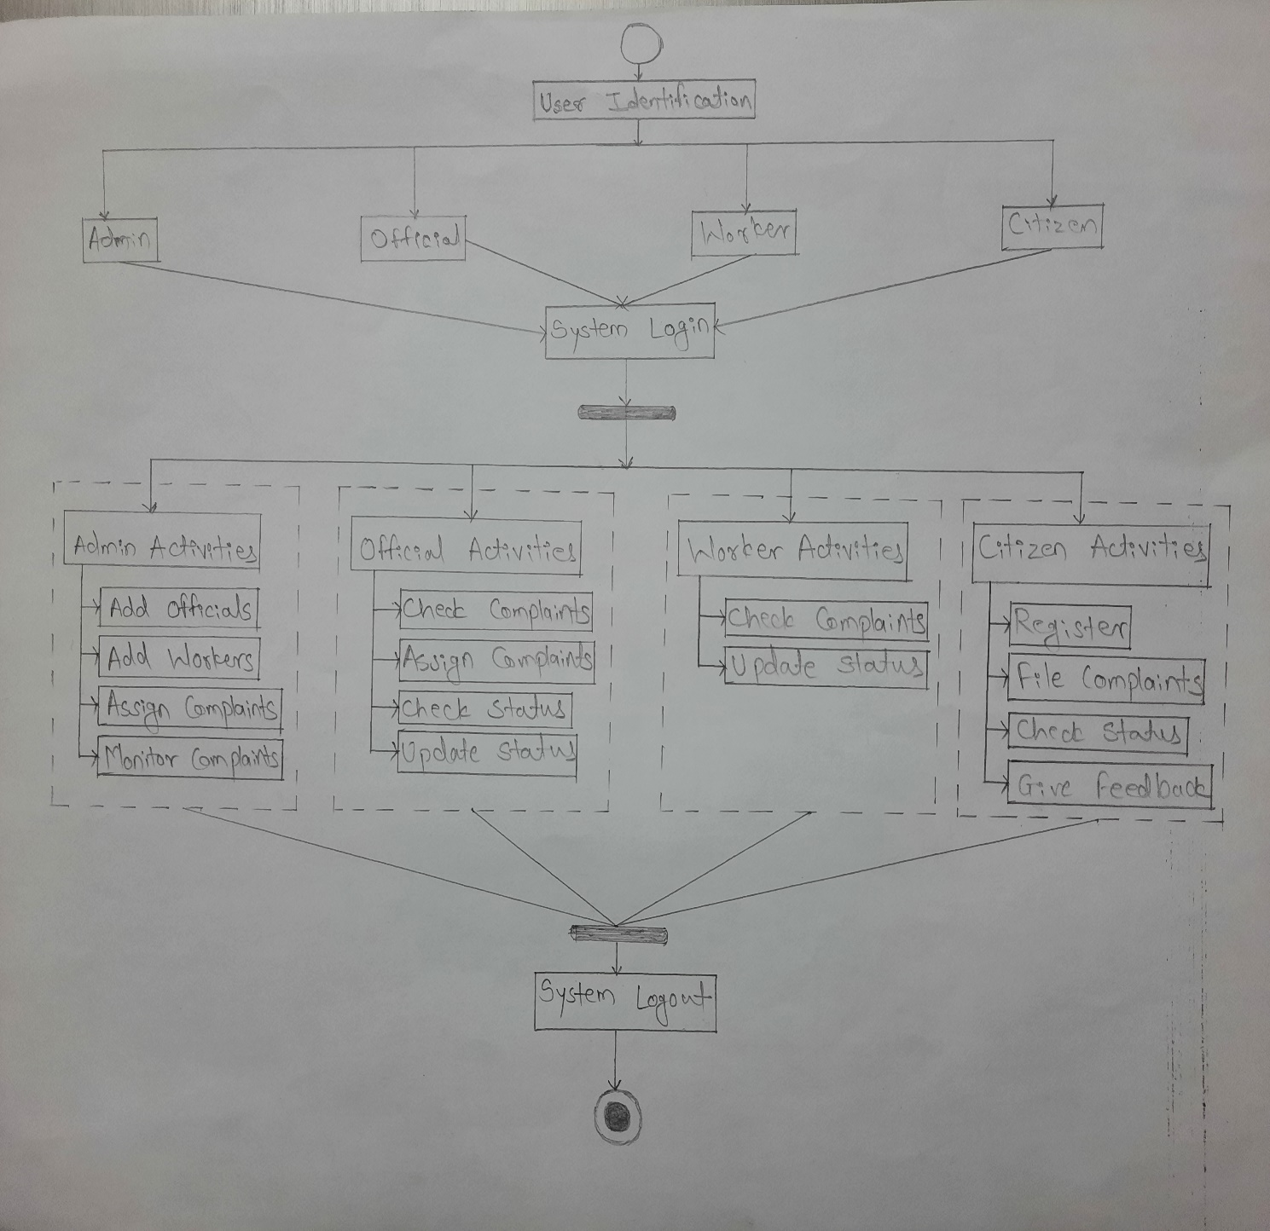

### Figure: Activity Diagram

# SYSTEM ANALYSIS

System analysis is the process of gathering and interpreting facts, diagnosing problems, and using the information to recommend improvements on the system. System analysis is a problem-solving activity that requires intensive communication between the system users and system developers.

System analysis or study is an important phase of any system development process. The system is viewed as a whole, the inputs are identified, and the system is subjected to close study to identify the problem areas. The solutions are given as a proposal. The proposal is reviewed on user request and suitable changes are made. This loop ends as soon as the user is satisfied with the proposal.

## EXISTING SYSTEM

The current system for social complaints is maintaining pen and paper data to add new officials or tenant or work staff. To circulate the notice Admin has to personally visit the officials or write it on the board of the office.

* + - It is less user-friendly.
    - Admin has to meet each member of the department and give notice or complaints.
    - It is difficult to gather each member of system at one place.
    - Admin has to maintain the whole paper work describing the details of issues and their categories.
    - It is a time-consuming process
    - Not in reach of distant users.

## PROPOSED SYSTEM

The proposed system provides friendly user interface to every member of the system and also citizens. The various other functionalities about Cross browsing, various categories suitable for different departments etc. This application will help all sectors of people which will provide them visibility and smooth functioning. This will be beneficial to all the members who travel abroad and who cannot be a part of each and every issue of the city. This application will travel worldwide and any members will have an access to it. Understanding the needs of the citizens and to overcome the manual work of the documentation and make it online which will be feasible and flexible and try to make it user friendly. Web-platform means that the system will be available for access 24/7 except when there is a temporary server issue which is expected to be minimal.

## SYSTEM REQUIREMENT SPECIFICATION

1. **Introduction**

The SRS Document contains the complete software requirement for social complaint portal. Social Complaints is a Web based Platform which is a single window platform wherein the citizens can easily register their complaints, provide suggestion or feedback on various issues and connect with local. Government Officials to resolve any kind of issues. The platform allows citizens to upload the images and exact location of the problem, whereas the worker can upload the image when the work is completed. System supports google map integration to help the user to find out where is the exact problem location. System supports roles mainly as citizen, government officials, actual workers and administration who performs their respective roles. System manages the complete end to end complaint management or complaint flow starting from citizen to the worker end, which helps in making the whole process transparent and flexible for the citizens and eliminates the delay in getting problem resolved.

* 1. **Objective**

1) Visual Proof:

Capturing and uploading the snap of the problematic zone as a visual proof.

2) Complaint Management:

Department Wise Sorting

Schedule Complaint

3) Update Status

4) Status

User can see status regarding complaints

5) Worker Allocation

6) Officials will assign task to the workers

7) Analytics Chart of

All Complaints/Resolved Complaints/Pending Complaints

* 1. **Intended Audience**
* Any Audience for the projects, where this module is integrated.
* This app is easy to use for everyone and available easily
* This app is web-based app so it must provide a user interface that will be accessible through any internet browser so we can that tracks current citizen complaint information.
  1. **Intended Use**

It is not convenient for the citizen to go to the official in different department to complain but with this website the citizen can register his complaint to any department from anywhere.

* 1. **Scope**

The scope of the project includes the following:

• Any citizen can use this system.

• citizen can register the complaints and also track the complaint status

• The Admin Module can be reused for projects as well which have many users with different rights. Hence it is reusable.

1. **Overall Description**
   1. **User Needs**

* For the social complaint portal project, the user needs to have a platform where they can easily submit their complaints related to various social issues
* The user should be able to create an account, login, and submit their complaint along with relevant details such as location, time, and supporting evidence such as photos or videos.
* The user should also be able to track the progress of their complaint and receive updates on the status of the complaint. Additionally, users may need to have the ability to provide feedback or follow up on their complaints. Overall, the user needs a user-friendly, secure, and efficient platform where they can submit their complaints and feel confident that their concerns are being addressed.
  1. **Assumptions and Dependencies**
* A general knowledge of basic computer skills and internet is required to use the product.
* Non-availability of required resources.
* Complex user interface may lead to the increased difficult

1. **System Features and Requirements**
   1. **Functional Requirements: -**

Social complaint portal consists of four modules described below: -

1. **Admin**
2. Official Registration - Admin can register official according to department.
3. Worker Registration - Admin can register worker according to department.
4. Update Official – Admin can update the official information.
5. Update Worker – Admin can update the worker information.
6. View complaint list – Admin can view all the complaint.
7. Add New Complaint category - Admin can add any Complaint category with specific department.
8. Logout - Admin can leave the session using logout
9. **Official**
10. Login – Official can join the session using login.
11. View complaint list - Official can view all the complaint respective to that department.
12. Assign worker – Official can assign worker respective to that department.
13. Logout - Official can leave the session using logout.
14. **Worker**
15. Login – Worker can join session using login.
16. Update status – Worker can update the status of complaint.
17. Completed and closed – Worker can close the complaint after completion.
18. Visual proof - Worker can add visual proof of completed work.
19. Logout -Worker can leave the session using logout.

**d. Citizen**

1. Citizen registration – new user can register themselves.
2. Login – Citizen can join session using login.
3. Register complaint – Citizen can register complaint with the image.
4. Complaint status – Citizen can see the complaint status with complaint id which is generated when he raise the complaint.
5. Logout -Worker can leave the session using logout.
   1. **External Interface Requirements: -**

* User Interface- The Social complaint portal System web server must provide a user interface that will be accessible through any internet browser, the major ones being Google Chrome and Internet Explorer.
* Hardware Interface- All components able to be executed on personal computers with Window OS platforms and other platforms like Linux, Unix.
* Software Interface- All the interfaces are the active server pages running with the internet browser. The Social complaint portal system must integrate with the database through SQL interface. The system will be hosted in a web server running on Window Server.
* Communication interface- Connection to the system will be over TCP/IP connection.
  1. **System Features: -**

Social complaint portal System gives the following features: -

* Citizen Details - A Social complaint portal System also has a comprehensive dashboard with a single view of citizen details.
* Complaint Management - The Social complaint portal System automates the entire complaint process. It helps you get rid of the tedious process of manually handling the complaint process.
* Complaint Tracking - Maintaining Complaint Tracking is simpler than ever! Generate charts for your administration and securely track the complaint. This will also minimize proxies and the hefty paperwork.
  1. **Non-Functional Requirements: -**
* Performance

The Social complaint portal shall be built upon the web development technique and put on the web server online. The system and the server must be capable of handling the real-time error functionality occurs by the defined users. In addition, the system must be safety critical. All failures reported by the server side must be handled instantaneously to allow for user and system safety.

* Reliability

The system is safety critical. If it moves out of normal operation mode, the requirement to drop or down the server and fix it as soon as possible and open it again. This emergency behavior shall not occur without reason.

* Availability

When in normal operating conditions, request by a user for an online system shall be handled within 1 second. Immediate feedback of the systems activities shall be communicated to the user by clearing the system and giving space n speed to their hospitality.

* Security

There shall be a strong security mechanism should be place in the server side of the system to keep unwanted users to hack or damage the system. However, all users of the system give and store the details of privacy related to personal information and many other. However, our system can be accessed online so we need very secured system as far as security is concerned.

**4. Use-Case Diagram**

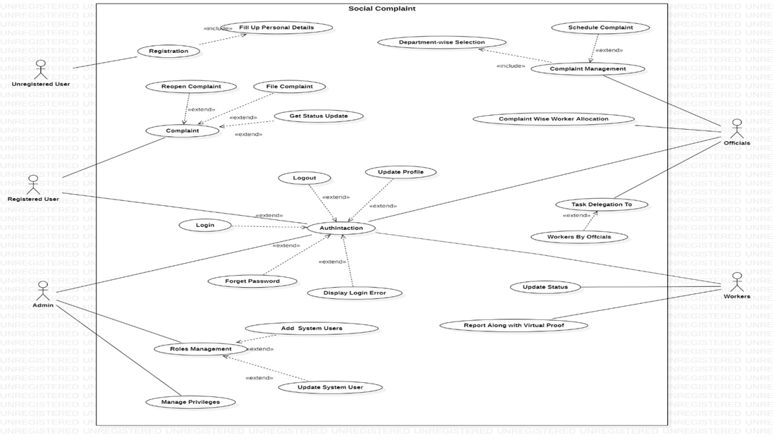

# SYSTEM DESIGN

System design is the solution for the creation of a new system. This phase focuses on the detailed implementation of the feasible system. Its emphasis on translating design. Specifications to performance specification. System design has two phases of development.

* Logical Design
* Physical Design

During logical design phase the analyst describes inputs (sources), outputs(destinations), databases (data sores) and procedures (data flows) all in a format that meets the user requirements. The analyst also specifies the needs of the user at a level that virtually determines the information flow in and out of the system and the data resources. Here the logical design is done through data flow diagrams and database design. The physical design is followed by physical design or coding. Physical design produces the working system by defining the design specifications, which specify exactly what the candidate system must do. The programmers write the necessary programs that accept input from the user, perform necessary processing on accepted data and produce the required report on a hard copy or display it on the screen.

## INPUT AND OUTPUT DESIGN

#### INPUT DESIGN:

Input design is the link that ties the information system into the world of its users. The input design involves determining the inputs, validating the data, minimizing the data entry and provides a multi-user facility. Inaccurate inputs are the most common cause of errors in data processing. Errors entered by the data entry operators can be controlled by input design. The user-originated inputs are converted to a computer-based format in the input design. Input data are collected and organized into groups of similar data. Once identified, the appropriate input media are selected for processing. All the input data are validated and if any data violates any conditions, the user is warned by a message. If the data satisfies all the conditions, it is transferred to the appropriate tables in the database. In this project the student details are to be entered at the time of registration. A page is designed for this purpose which is user friendly and easy to use. The design is done such that users get appropriate messages when exceptions occur.

#### OUTPUT DESIGN:

Computer output is the most important and direct source of information to the user. Output design is a very important phase since the output needs to be in an efficient manner. Efficient and intelligible output design improves the system relationship with the user and helps in decision making. Allowing the user to view the sample screen is important because the user is the ultimate judge of the quality of output. The output module of this system is the selected notifications.

# DATABASE DESIGN

* 1. **DATABASE**

Databases are the storehouses of data used in the software systems. The data is stored in tables inside the database. Several tables are created for the manipulation of the data for the system. Two essential settings for a database are

* Primary key - the field that is unique for all the record occurrences
* Foreign key - the field used to set relation between tables Normalization is a technique to avoid redundancy in the tables.

## SYSTEM TOOLS

The various system tools that have been used in developing both the front end and the back end of the project are being discussed in this chapter.

#### FRONT END:

React is a library which is developed by Facebook are utilized to implement the frontend. React (also known as React.js or ReactJS) is a [free and open-source](https://en.wikipedia.org/wiki/Free_and_open-source_software) [front-end](https://en.wikipedia.org/wiki/Free_and_open-source_software) [JavaScript](https://en.wikipedia.org/wiki/JavaScript_library) [library](https://en.wikipedia.org/wiki/JavaScript_library) for building [user interfaces](https://en.wikipedia.org/wiki/User_interfaces) or UI components. It is maintained by [Facebook](https://en.wikipedia.org/wiki/Facebook%2C_Inc) and a community of individual developers and companies. React can be used as a base in the development of [single](https://en.wikipedia.org/wiki/Single-page_application) [page](https://en.wikipedia.org/wiki/Single-page_application) or mobile applications. However, React is only concerned with state management and rendering that state to the [DOM,](https://en.wikipedia.org/wiki/Document_Object_Model) so creating React applications usually requires the use of additional libraries for routing, as well as certain client-side functionality.

#### BACKEND:

The back end is implemented using MySQL which is used to design databases.

#### MySQL:

MySQL is the world's second most widely used open-source relational database management system (RDBMS). The SQL phrase stands for Structured Query Language.

#### Spring-Boot:

This is used to connect MYSQL and fetch data from database and store the data in database. The Spring Framework is a[n application framework](https://en.wikipedia.org/wiki/Application_framework) and [inversion of control container](https://en.wikipedia.org/wiki/Inversion_of_control) for the [Java](https://en.wikipedia.org/wiki/Java_platform) [platform.](https://en.wikipedia.org/wiki/Java_platform) The framework's core features can be used by any Java application, but there are extensions for building web applications on top of the [Java EE](https://en.wikipedia.org/wiki/Java_EE) (Enterprise Edition) platform. Although the framework does not impose any specific [programming model,](https://en.wikipedia.org/wiki/Programming_model) it has become popular in the Java community as an addition to the [Enterprise JavaBeans](https://en.wikipedia.org/wiki/Enterprise_JavaBeans) (EJB) model. The Spring Framework is Open-source Framework.

# 0 Level DFD

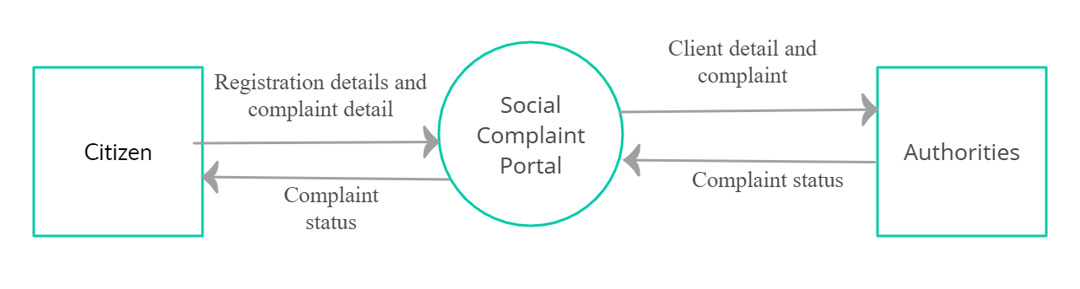

***Figure: 0 Level DFD***

# 1Level DFD for Admin

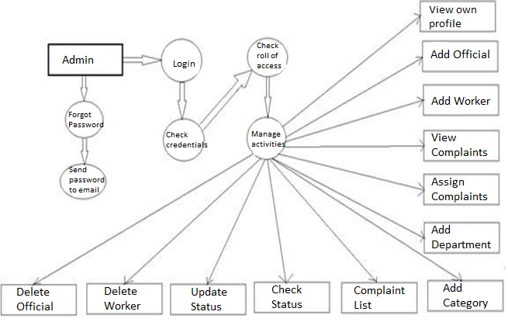

***Figure: 1 Level DFD for Admin***

# 1Level DFD for Official

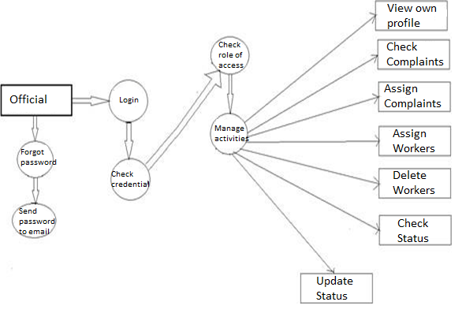

***Figure: 1 Level DFD for Official***

# 1Level DFD for Citizen

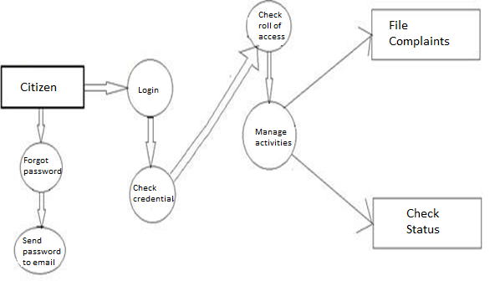

***Figure: 1 Level DFD for Citizen***

# E-R Diagram:

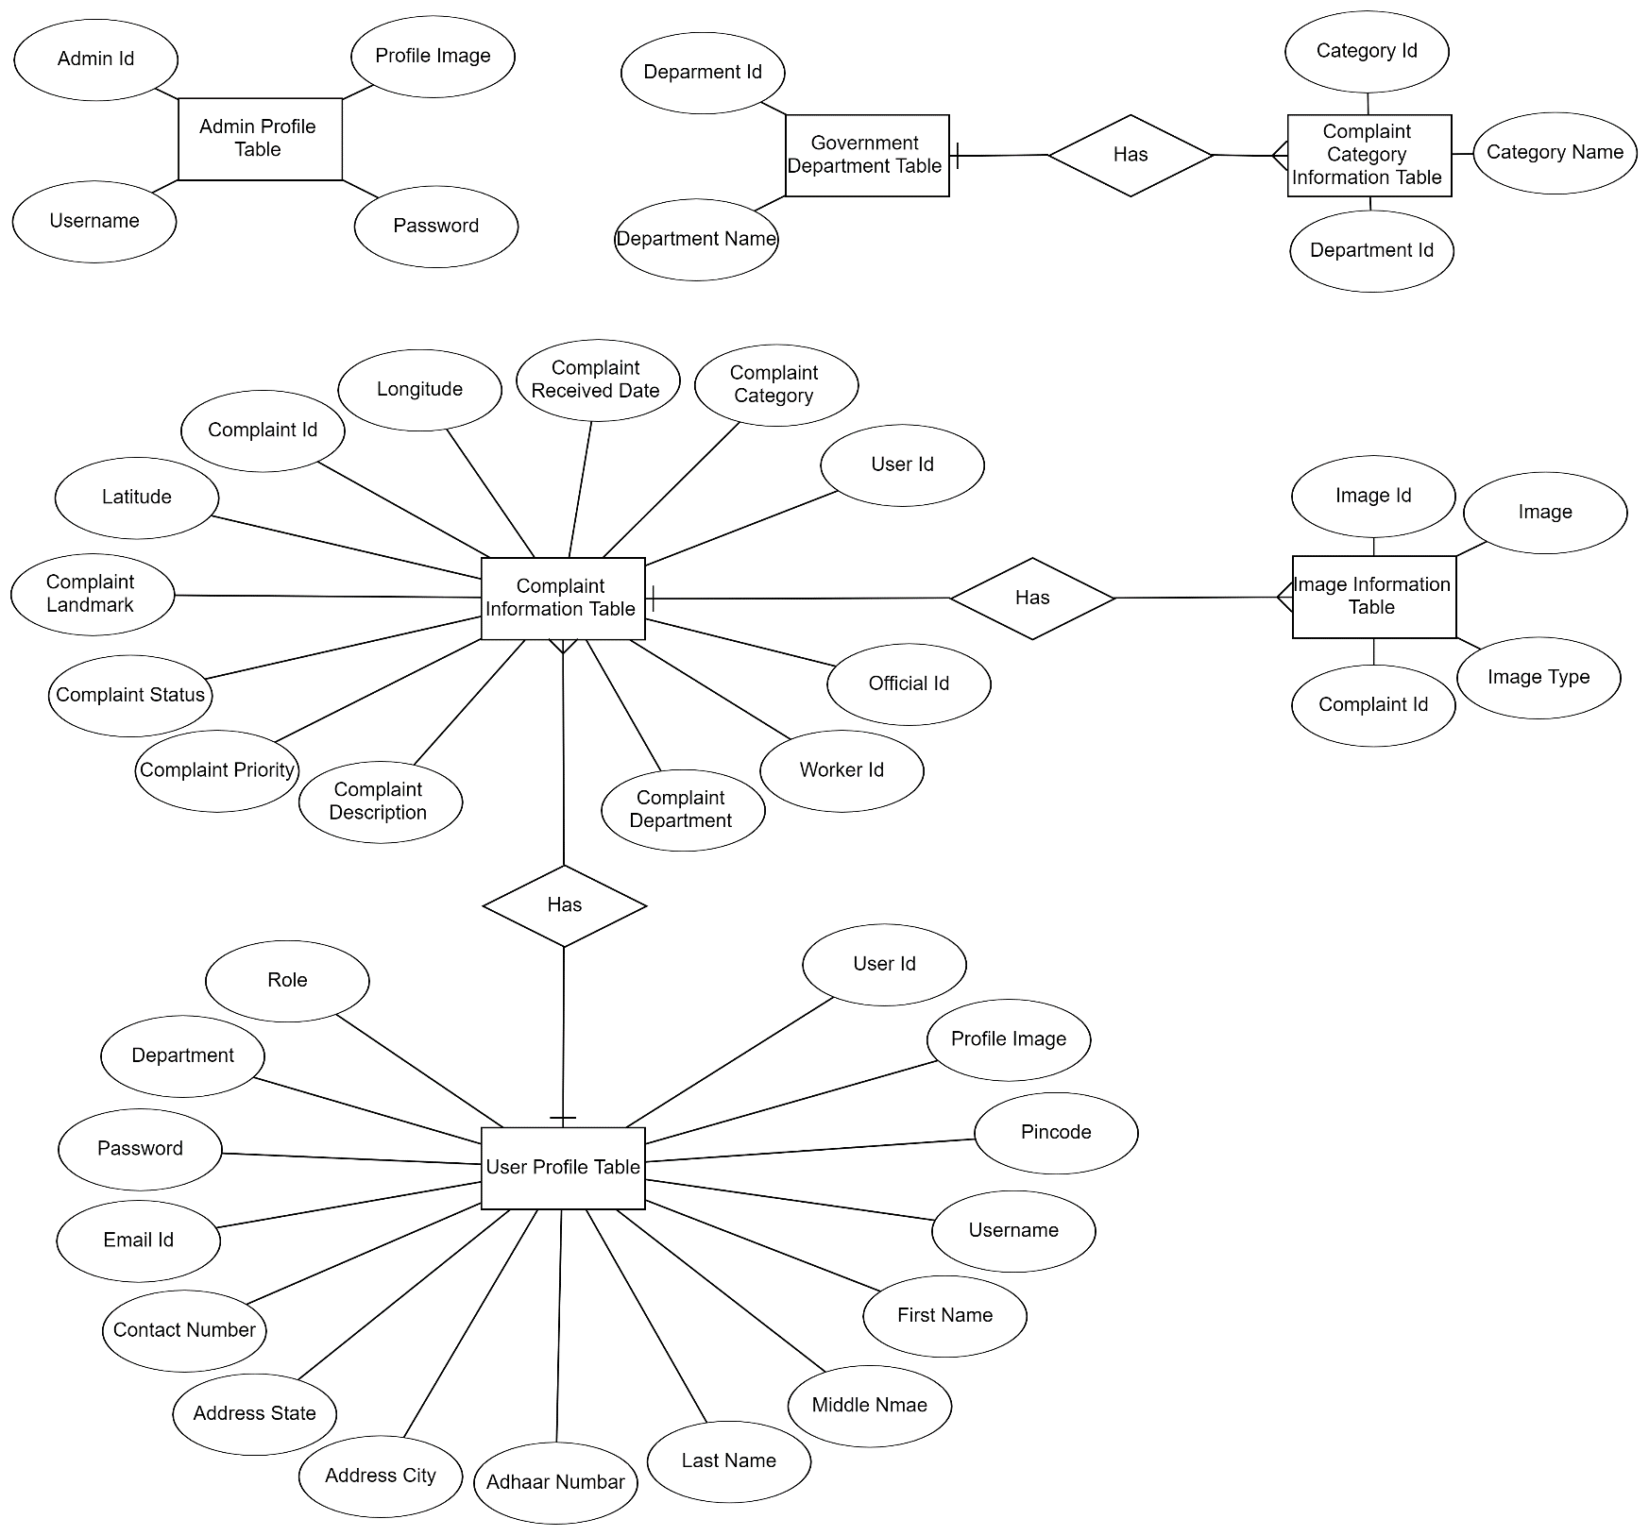

***Figure: E-R Diagram***

# Class Diagram

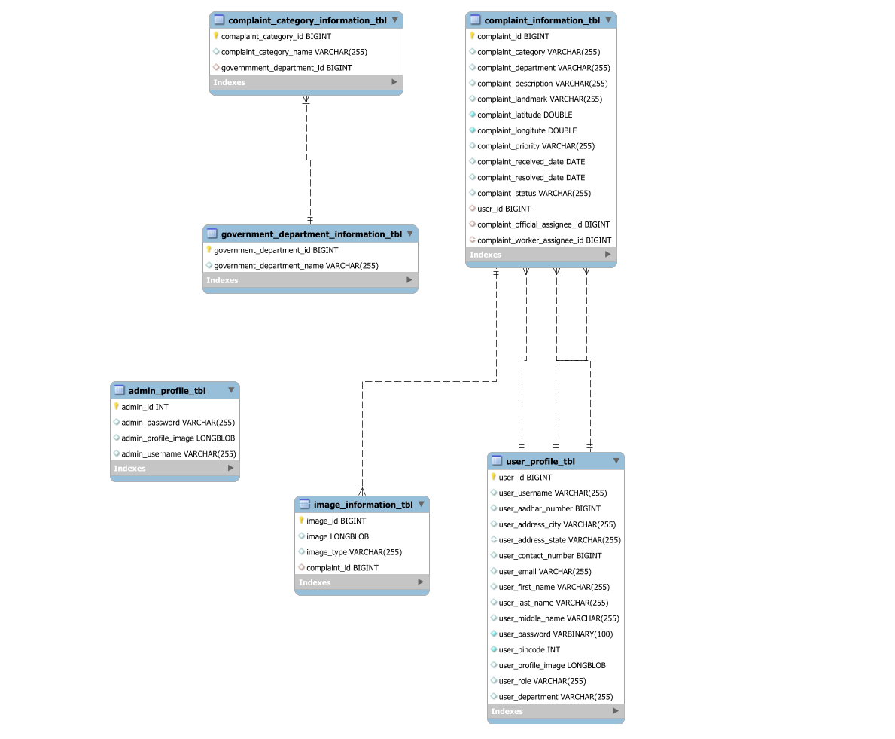

***Figure: Class Diagram***

# TABLE STRUCTURE:

## Tables:

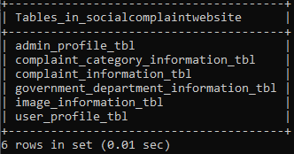

**Admin:**

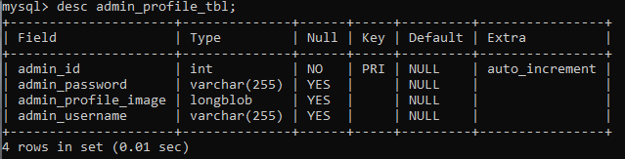

## User:

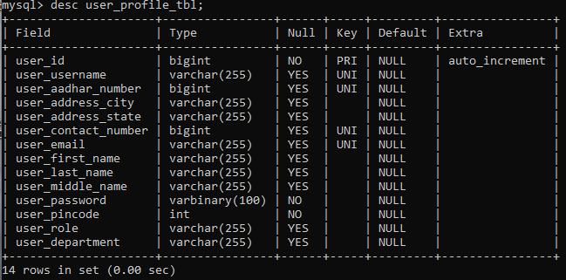

**Image:**

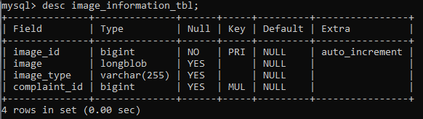

## Complaint Information:

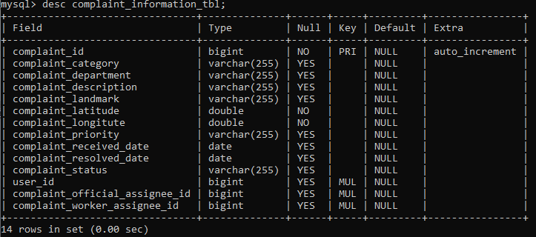

**Complaint Category:**

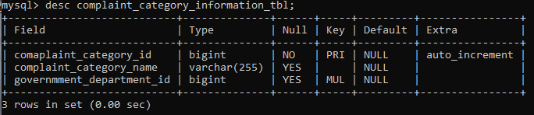

## Government Department:

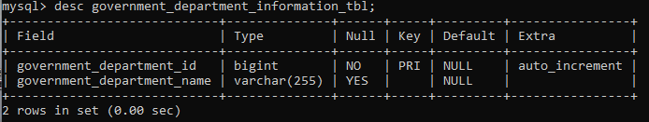

# PROJECT DIAGRAMS

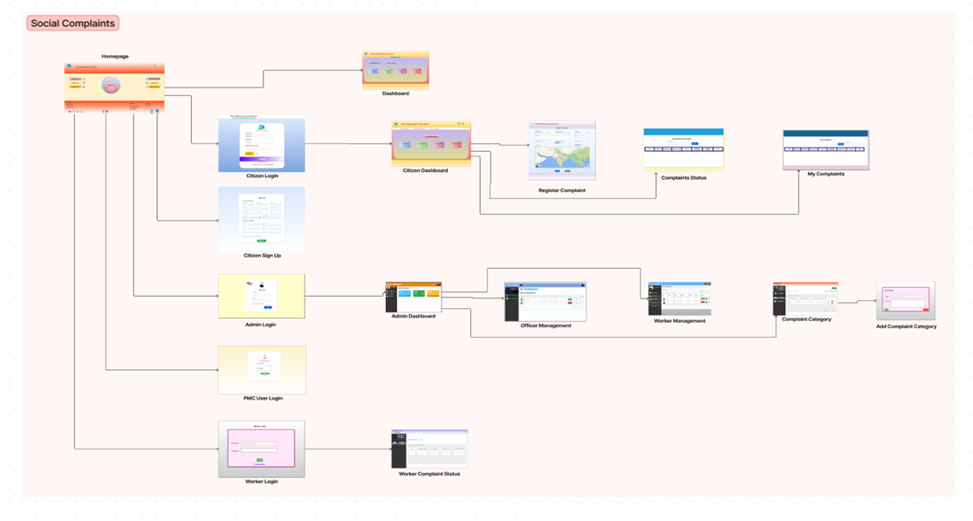

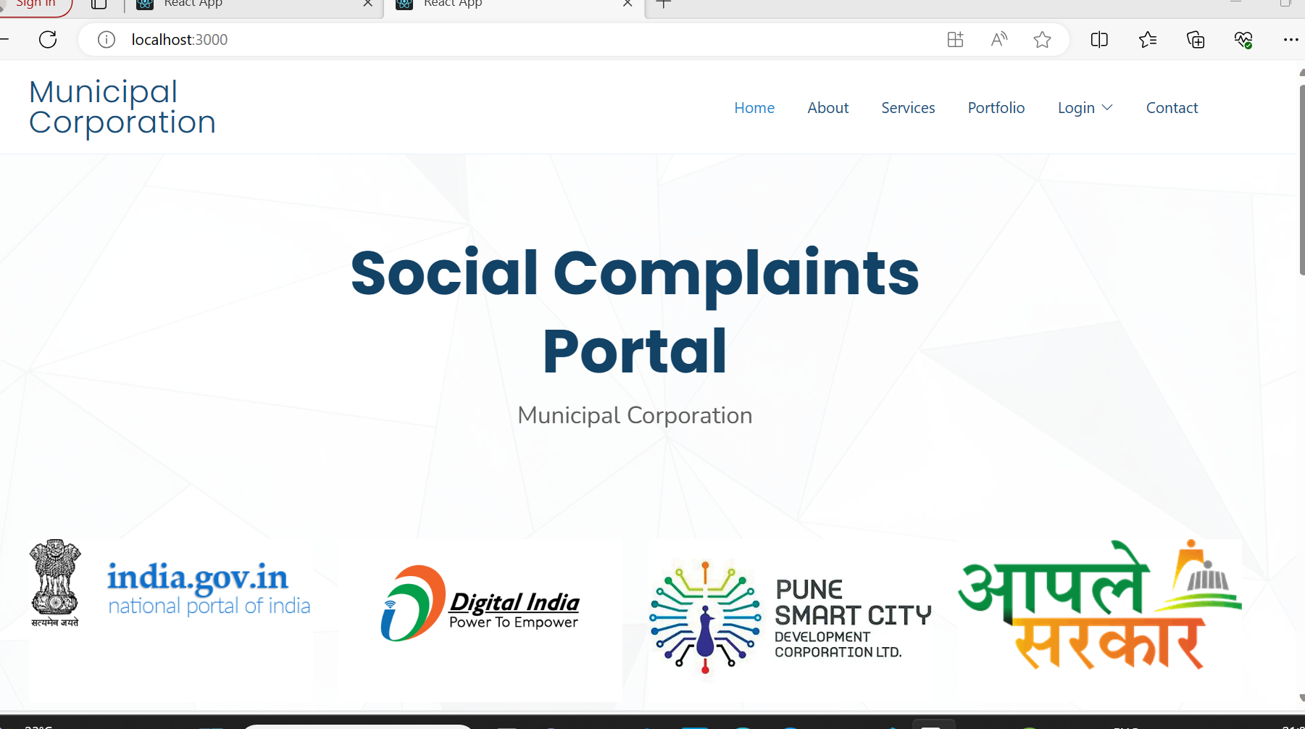

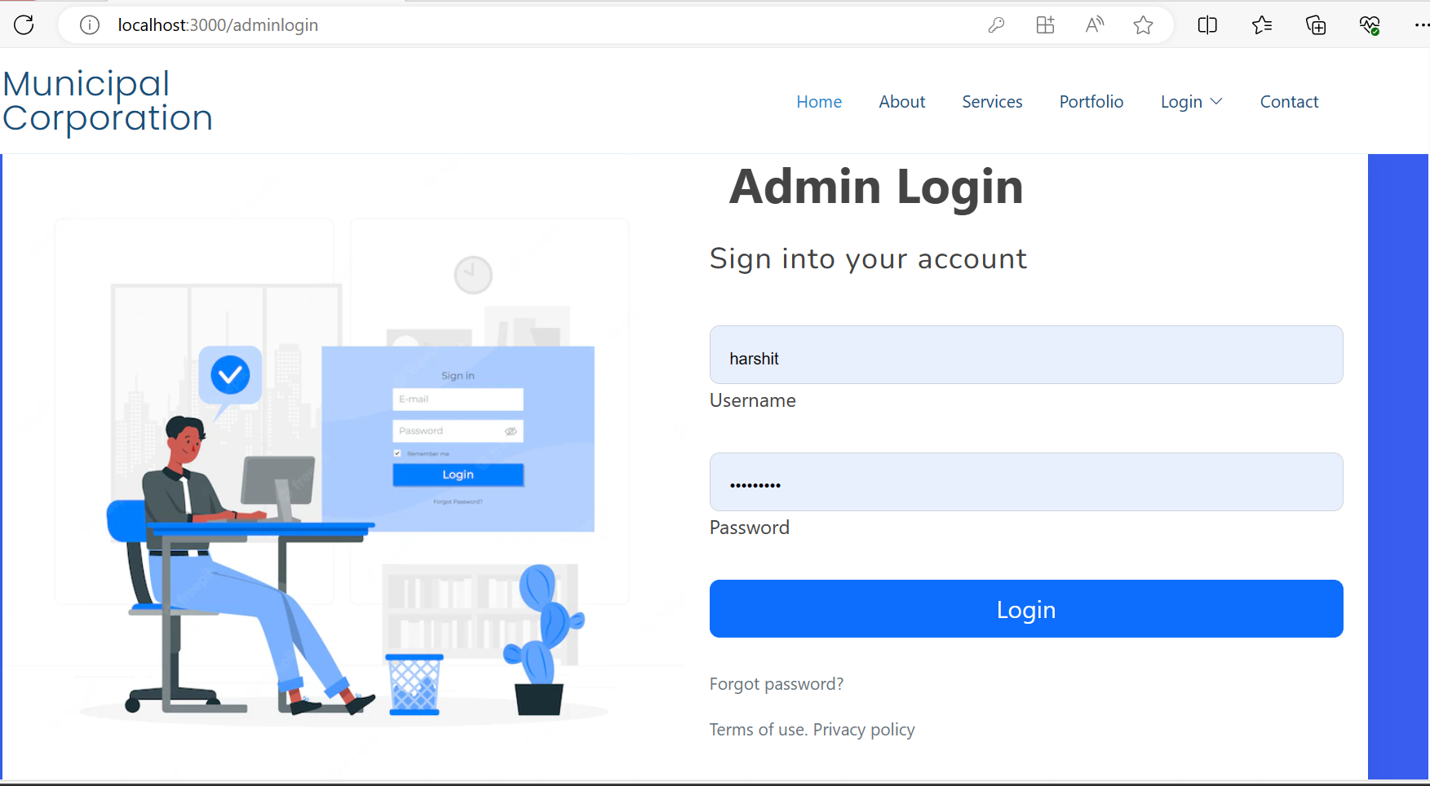

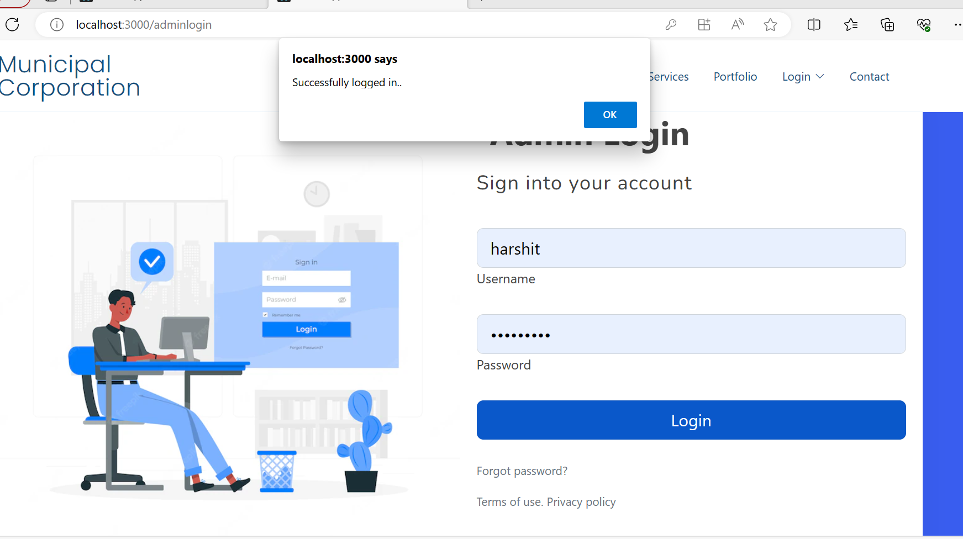

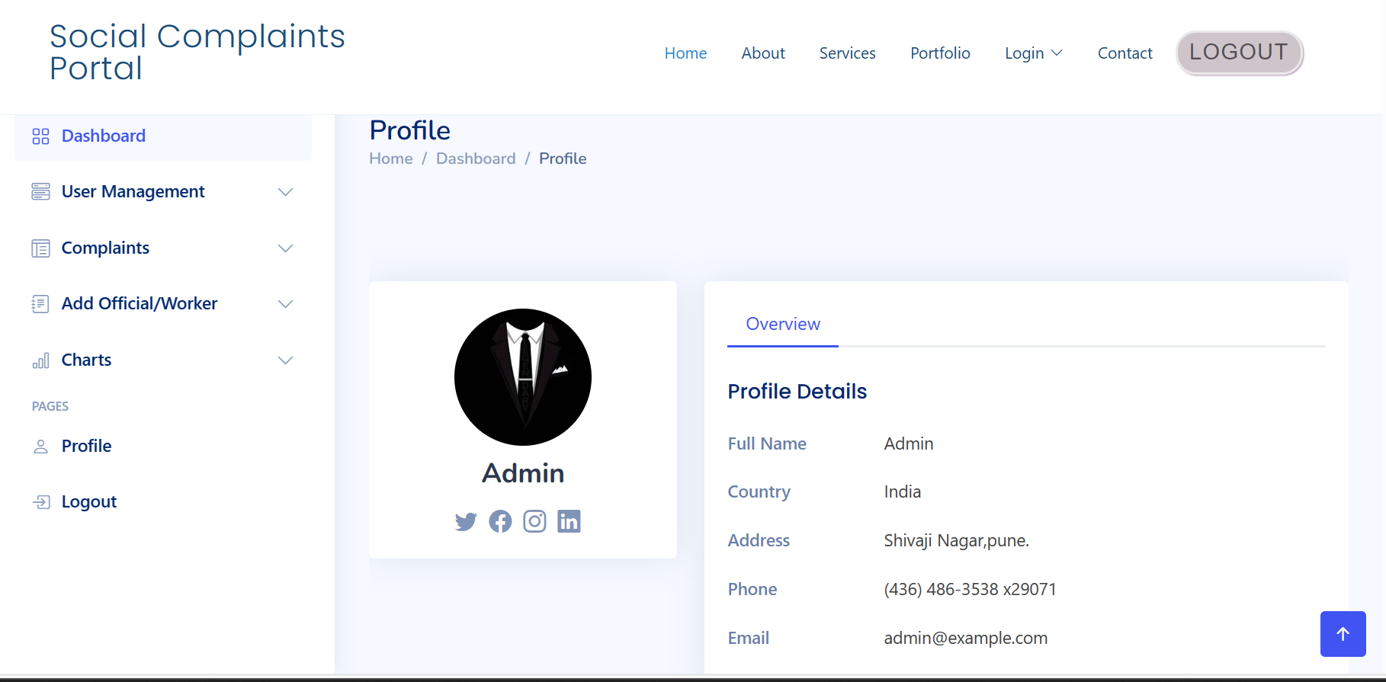

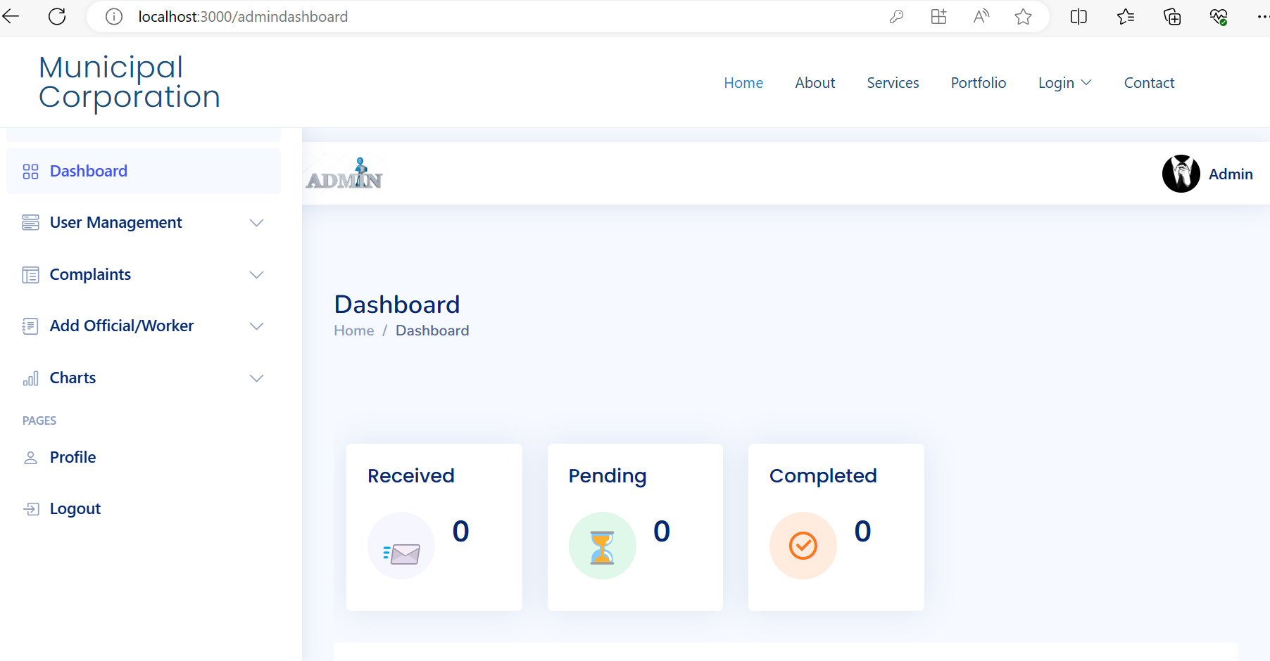

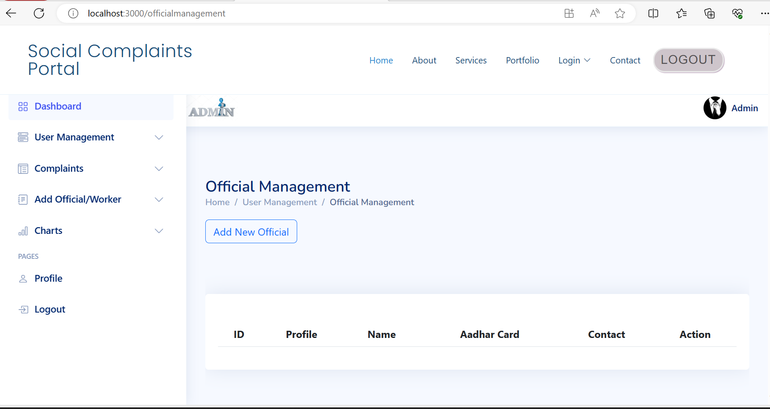

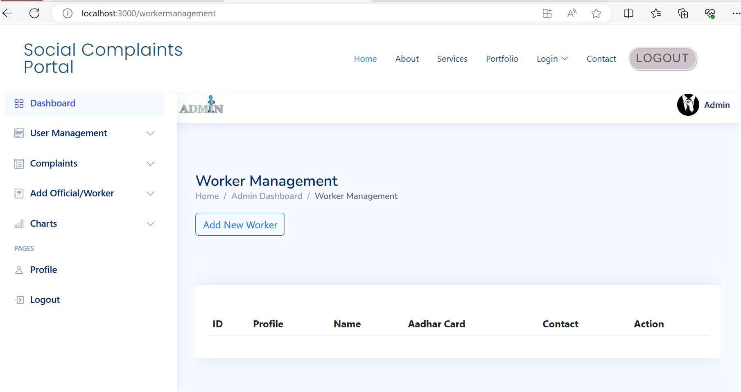

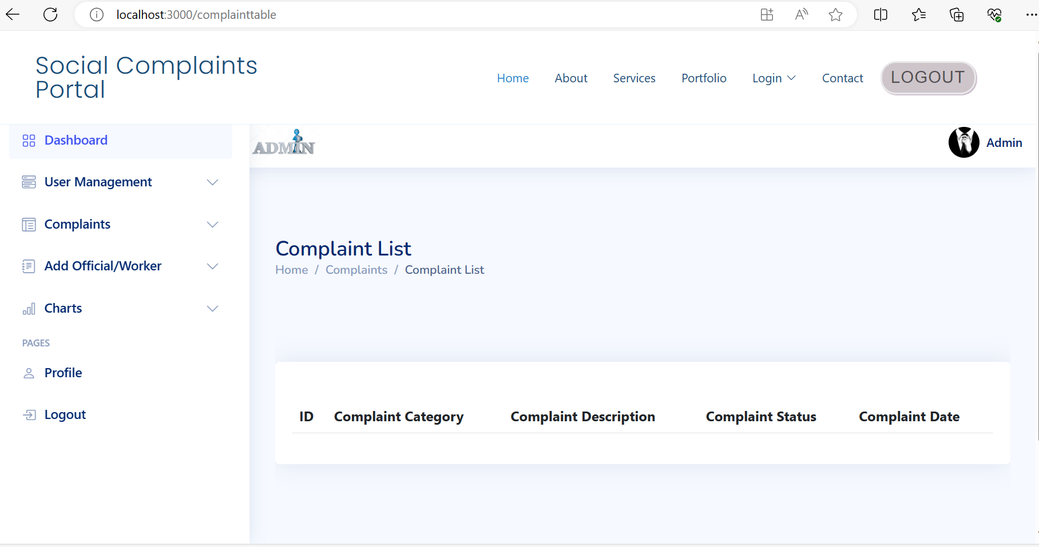

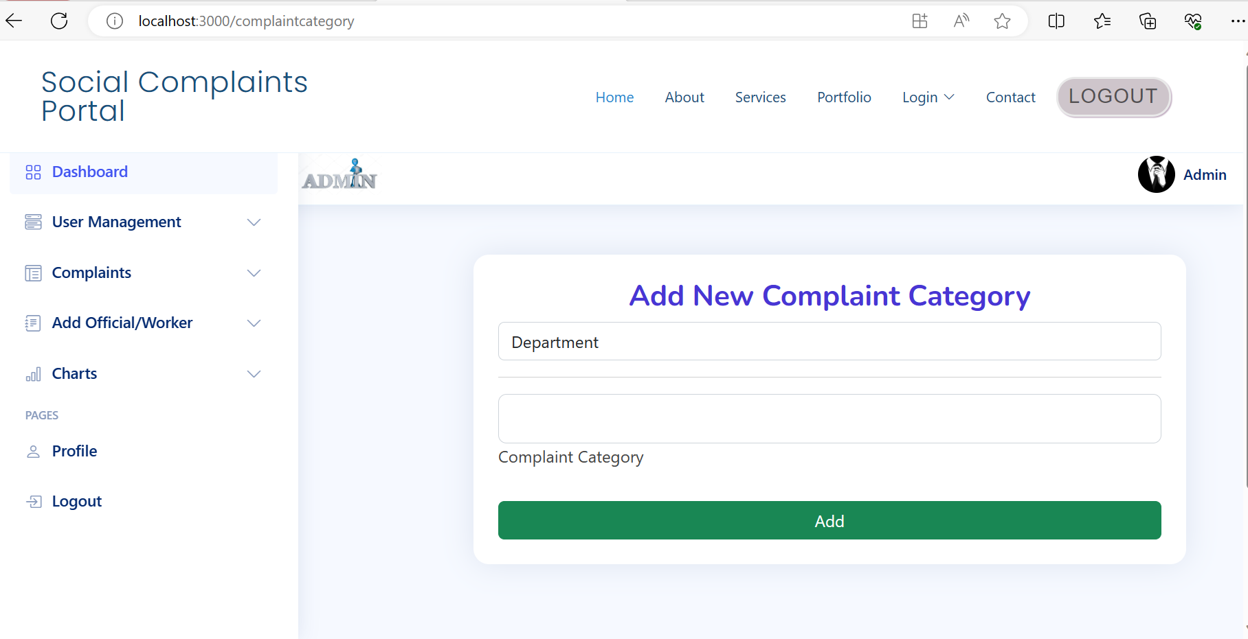

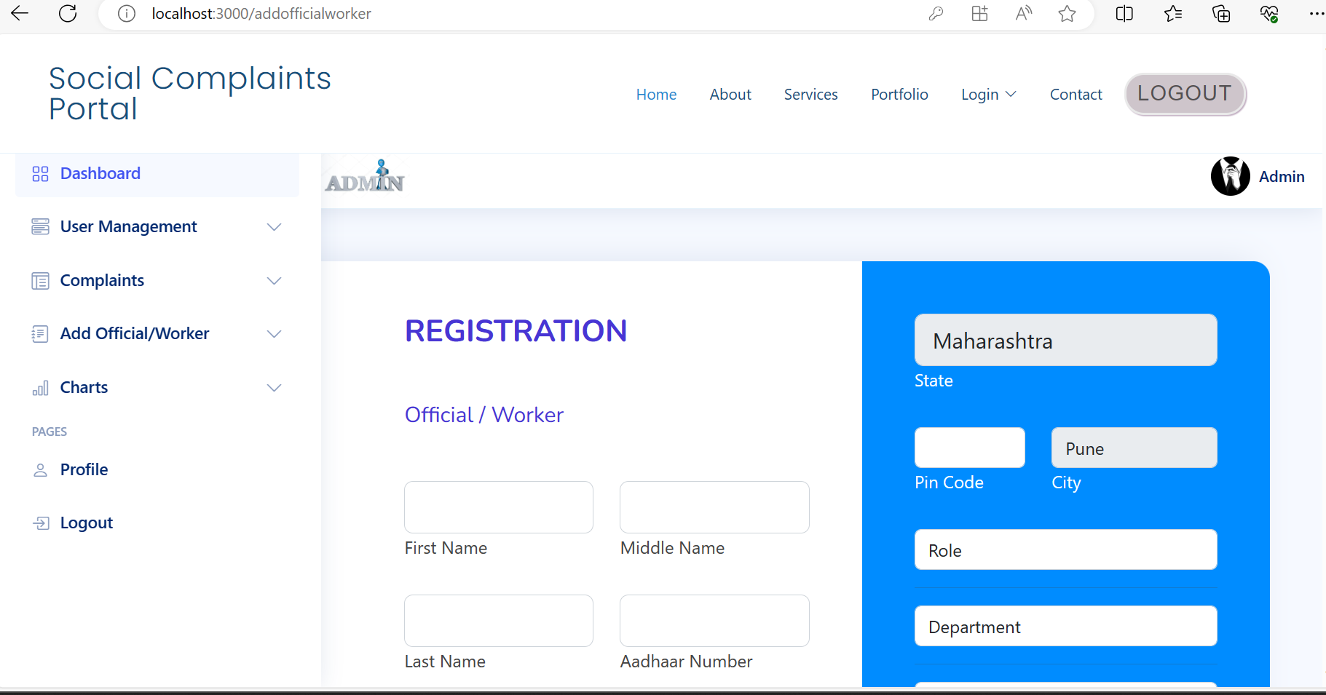

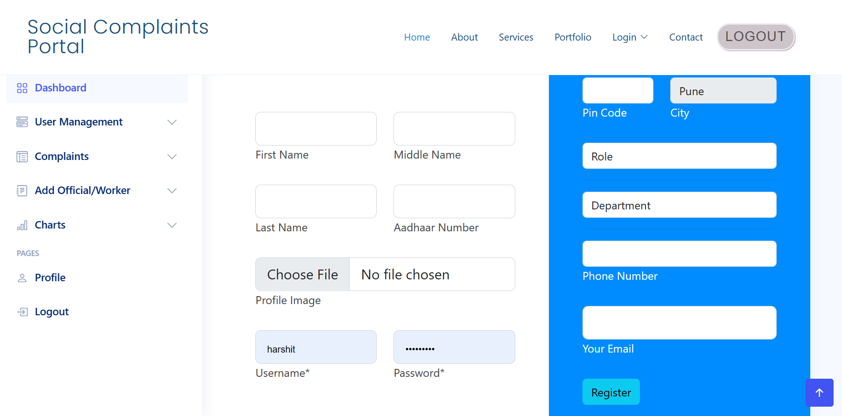

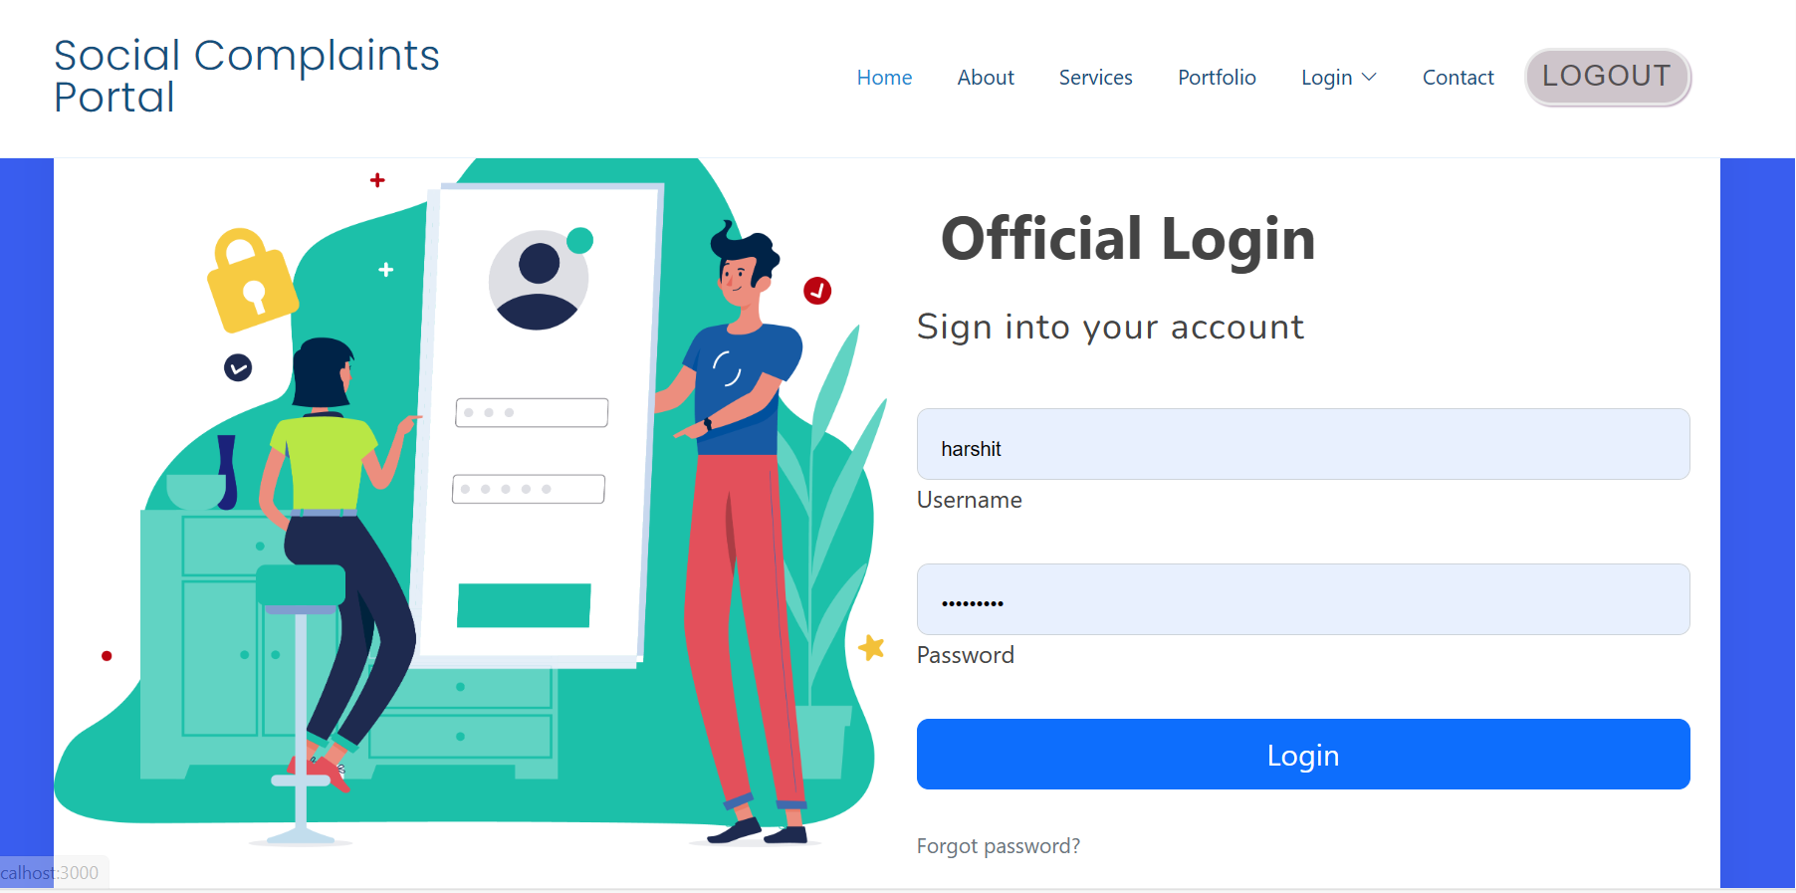

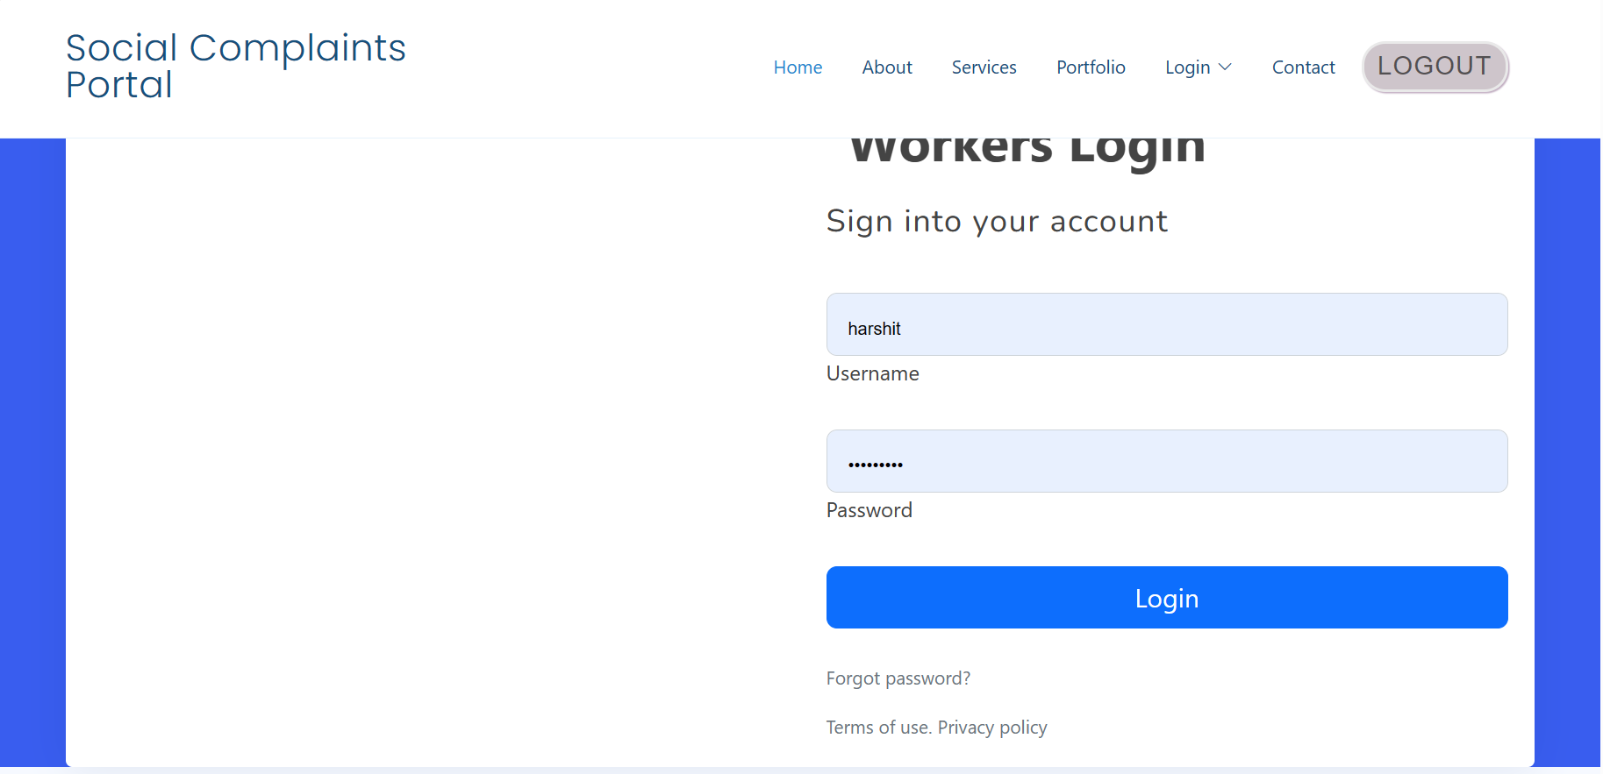

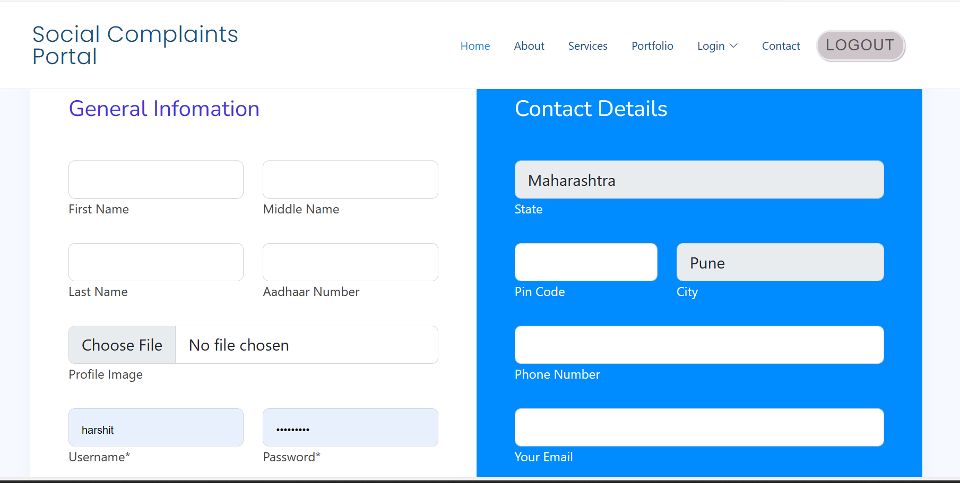

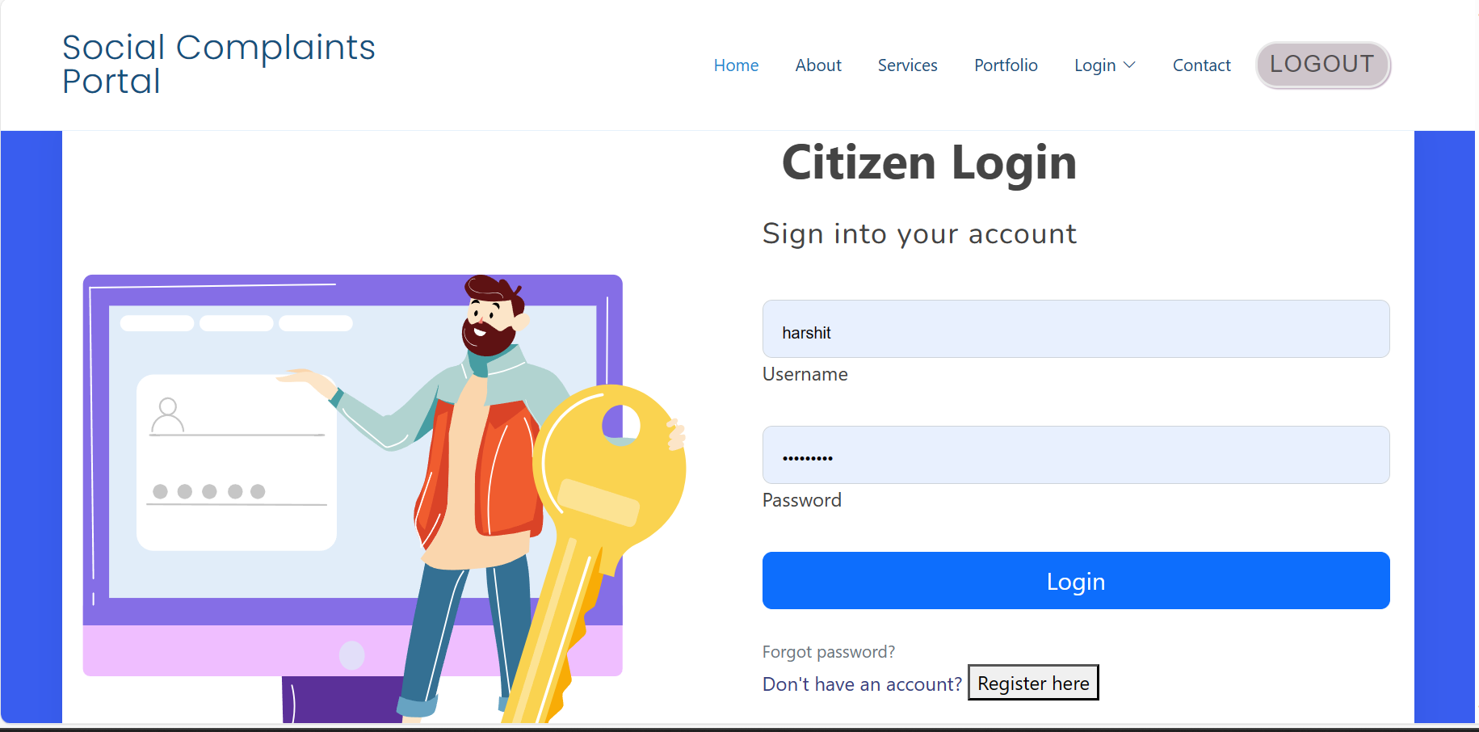

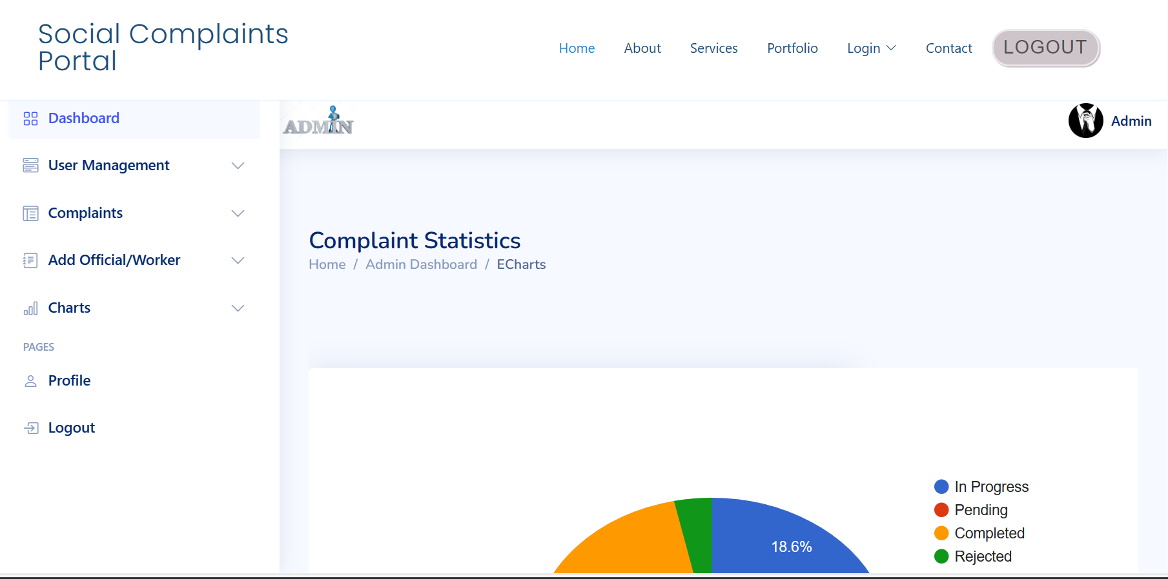

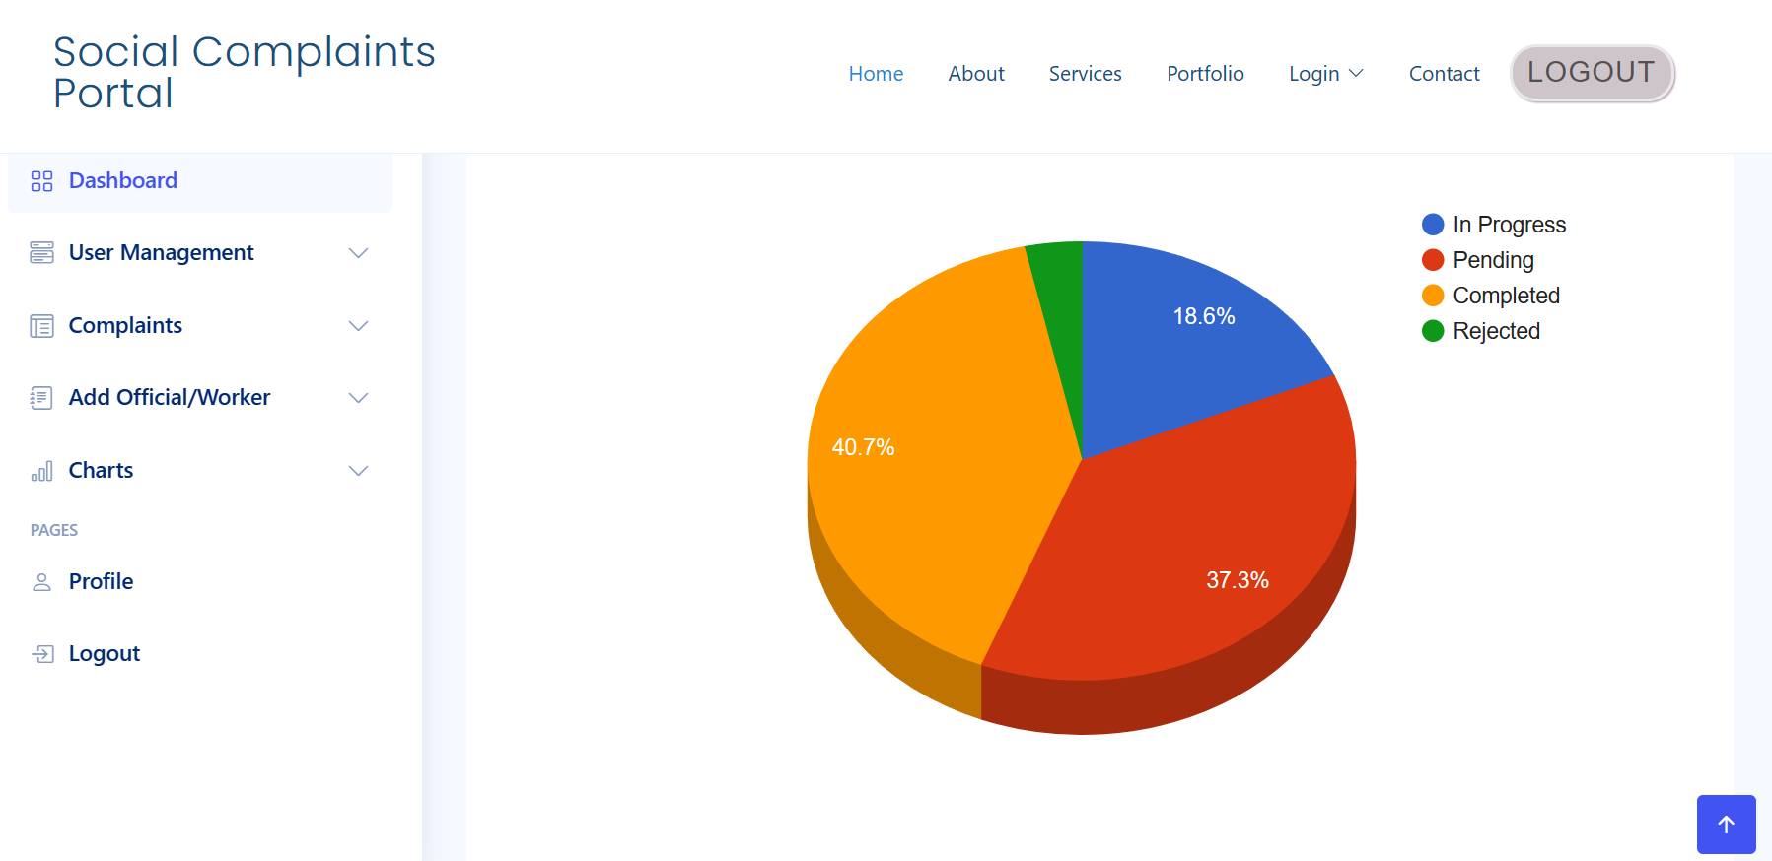

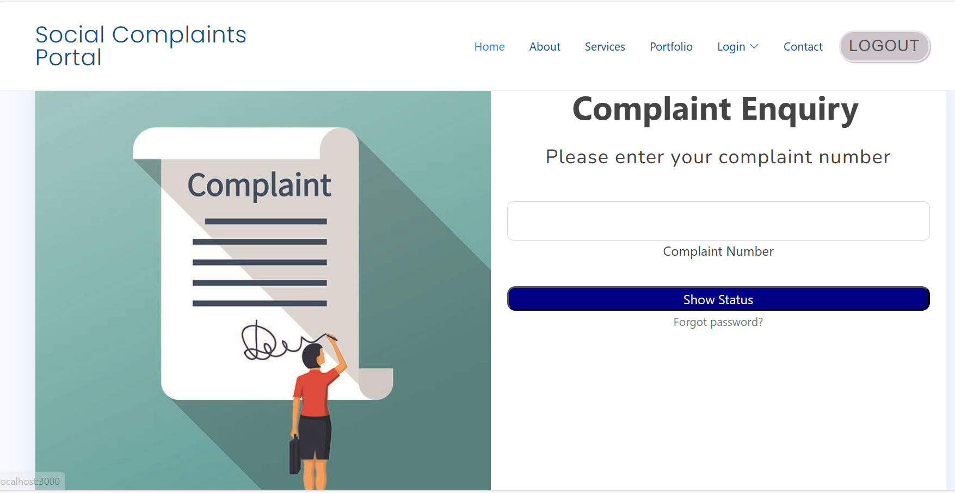

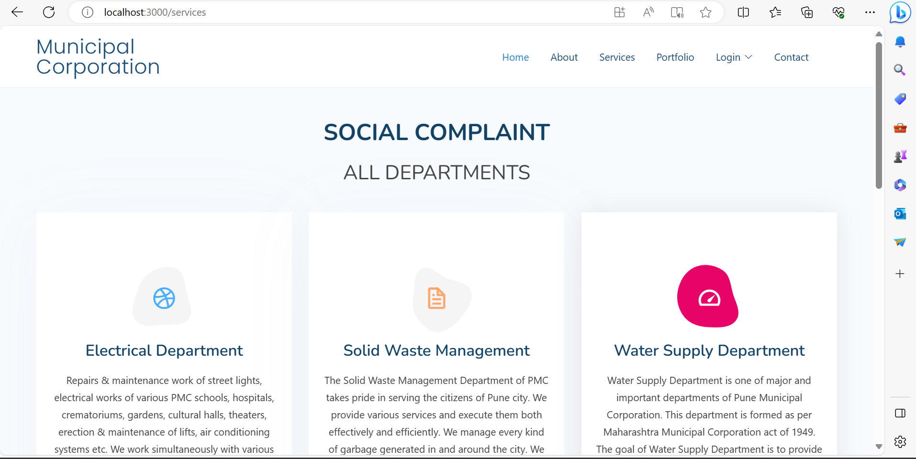

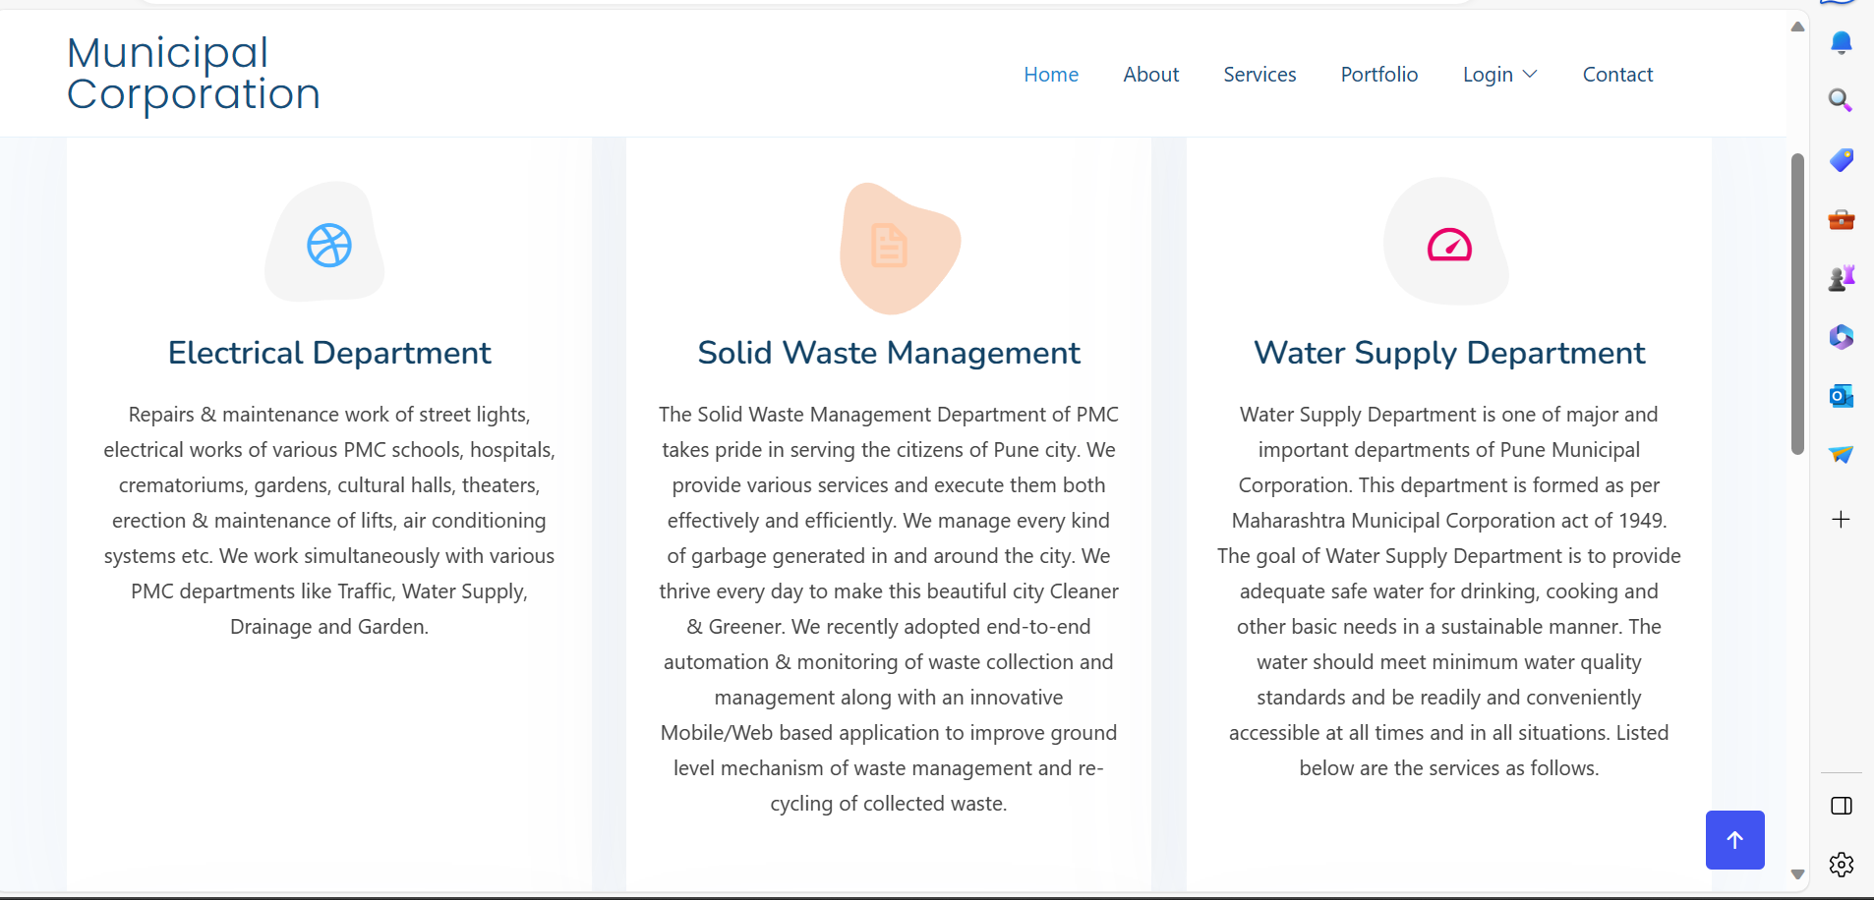



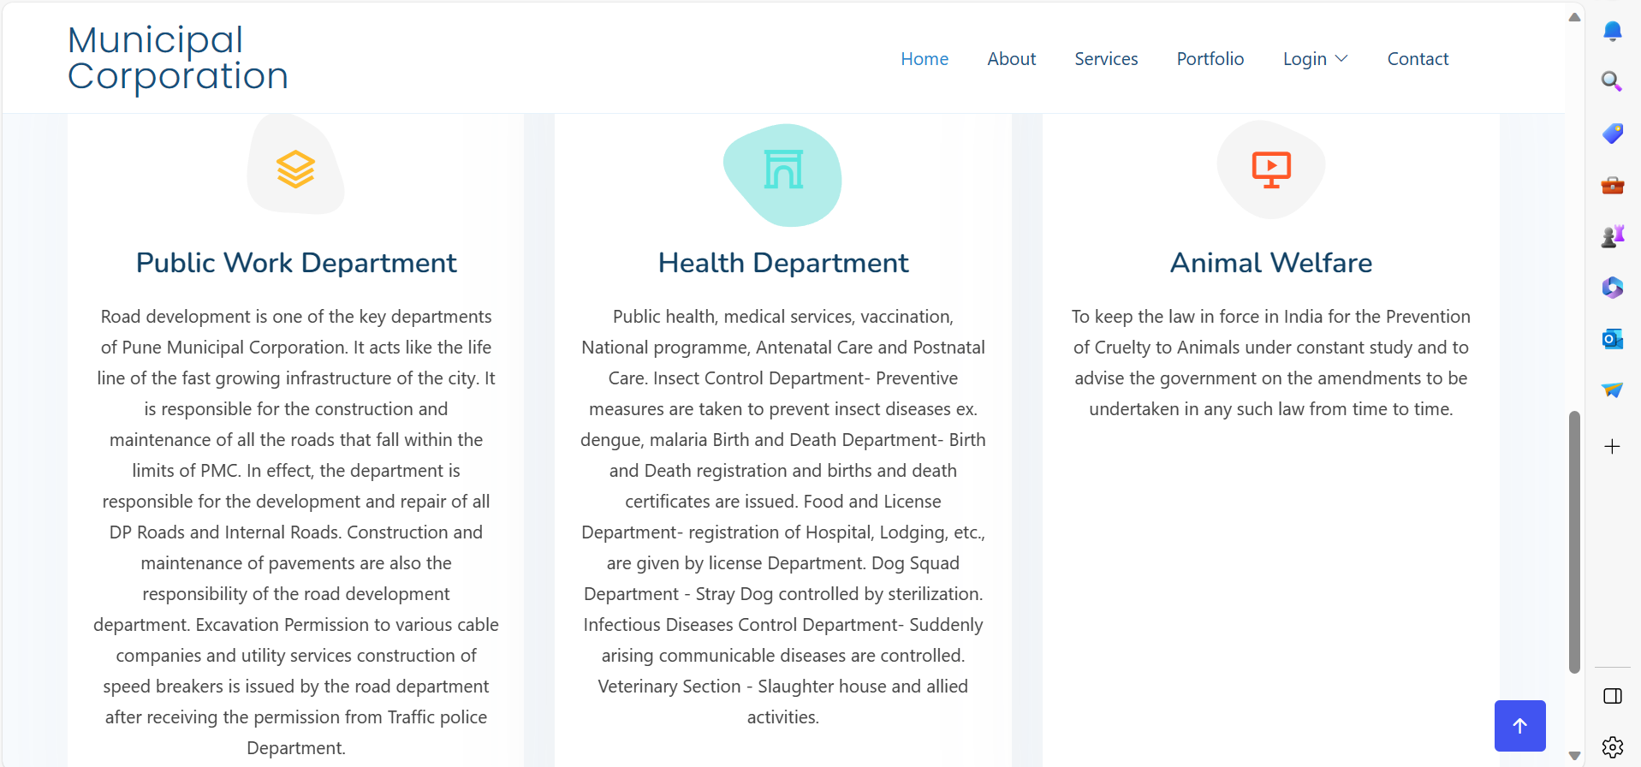

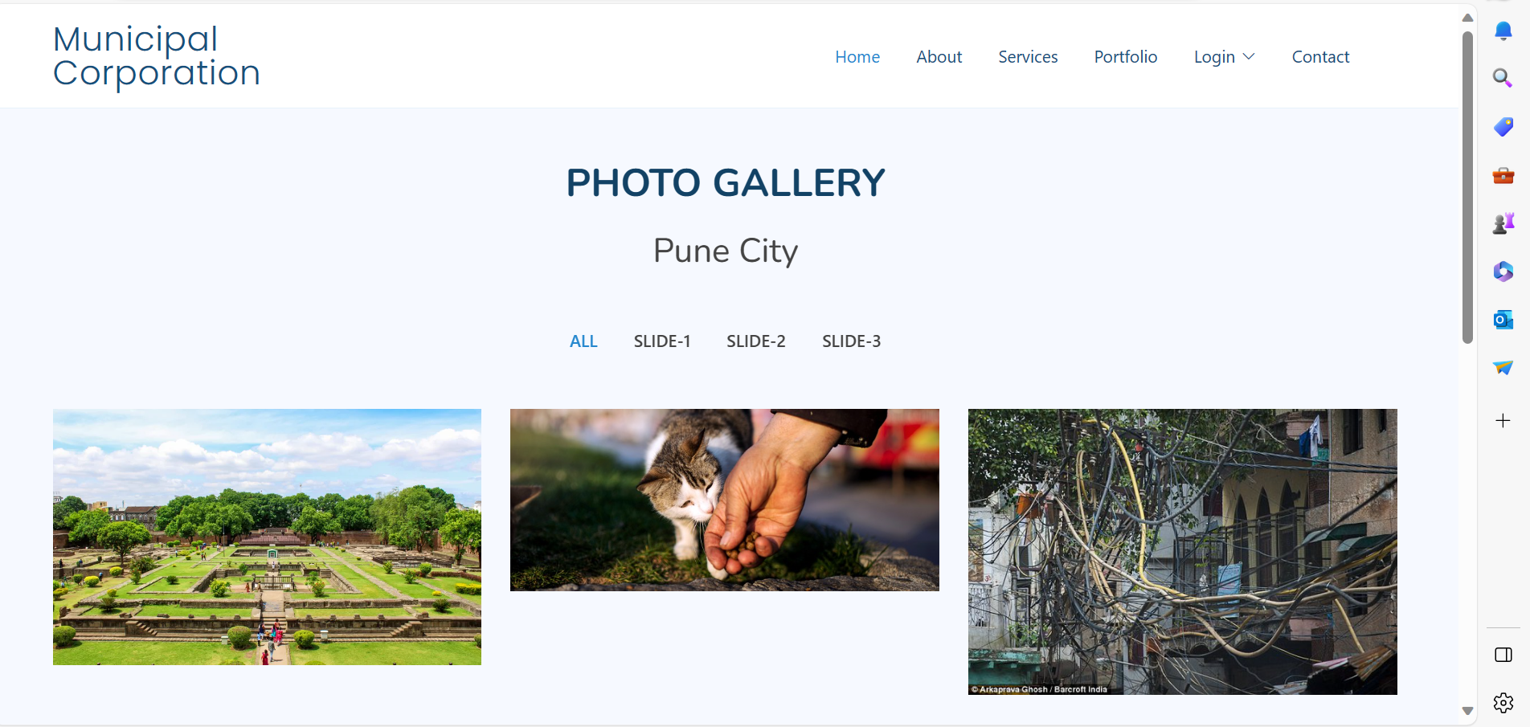

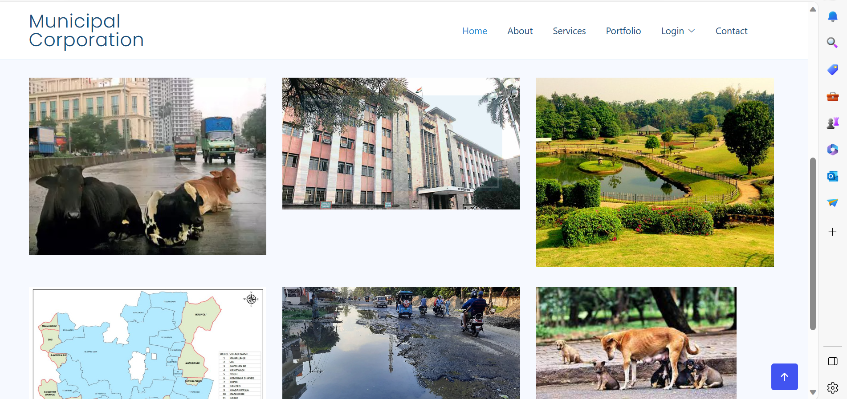

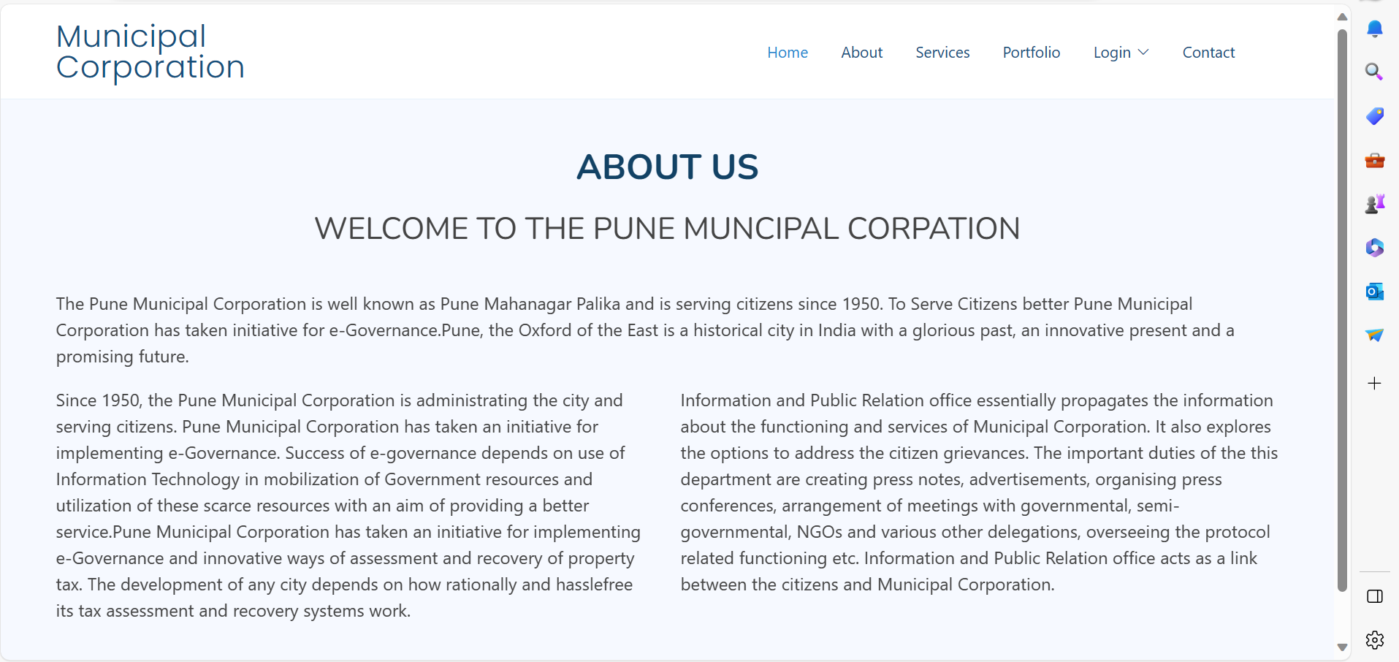

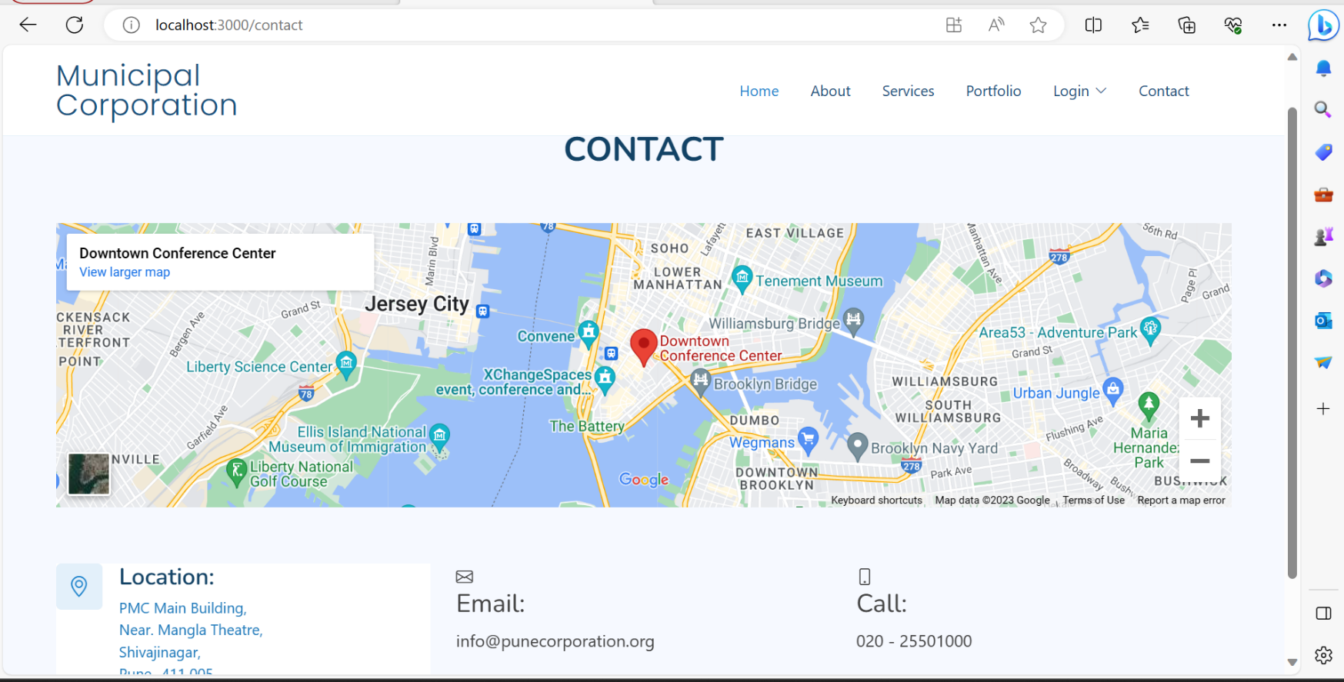

# CONCLUSION

The project entitled **Social Complaints Portal** was completed successfully.

The system has been developed with much care and free of errors and at the same time it is efficient and less time consuming. The purpose of this project was to develop a web application and an android application for purchasing items from a shop.

This project helped us in gaining valuable information and practical knowledge on several topics like designing web pages using React.js, usage of responsive templates, designing of android applications, and management of database using MySQL. The entire system is secured. Also, the project helped us understanding about the development phases of a project and software development life cycle. We learned how to test different features of a project.

This project has given us great satisfaction in having designed an application which can be implemented to any nearby shops or branded shops selling various kinds of products by simple modifications.

There is a scope for further development in our project to a great extent. A number of features can be added to this system in future like providing payment gateway for Tax payment and maintain their records in dashboard. Another feature we wished to implement was displaying notice board without login to system with the first page of “know about city”. Also wish to add each member profile with images store in data as well as officials with their department members information in the system. These features could have implemented unless the time did not limit us.

# REFERENCES

1. JavaScript Enlightenment, Cody Lindley-First Edition, based on JavaScript 1.5, ECMA-262,

Edition

1. Mc Graw Hill’s, Java: The complete reference 7thEdition, Herbert Scheldt
2. Complete CSS Guide, Maxine Sherrin and John Allsopp-O'ReillyMedia; September 2012

## ONLINE REFERENCE

* 1. [www.Google.com](http://www.google.com/)
  2. [www.w3school.com](http://www.w3school.com/)
  3. [www.javatpoint.com](http://www.javatpoint.com/)
  4. [www.stackoverflow.com](http://www.stackoverflow.com/)
  5. [www.reactbootstrap.com](http://www.reactbootstrap.com/)
  6. [www.doc.spring.io/spring-framework.com](http://www.doc.spring.io/spring-framework.com)
  7. [www.geekforgeeks.com](http://www.geekforgeeks.com/)
  8. [www.microsoftdoc.com](http://www.microsoftdoc.com/)
  9. [www.geeksforpratice.com](http://www.geeksforpratice.com/)